Chronological notes to accompany Old John Green’s Recollections.
Mark Norman, Ventnor fishmonger, amateur geologist and diarist, in his memoirs describes Green thus:
‘John Green was the village school master and parish clerk to the little church of St Lawrence He was a cripple had a red face and a nose of the Bardolphian type. He was a little man and was with one crooked leg and it will be seen that he had a remarkable retentive memory. In his early days was afflicted with convulsions.’
- April 15th.Naval Mutiny at Spithead.

Spithead
The mutiny at Spithead (an anchorage near Portsmouth) lasted from 16 April to 15 May, 1797. Sailors on 16 ships in the Channel Fleet, commanded by Admiral Lord Bridport, protested at the living conditions aboard Royal Navy vessels and demanded a pay rise.
Seamen's pay rates had been established in 1658, and due to the stability of wages and prices, they had still been reasonably competitive as recently as the Seven Years' War, 40 years earlier; however, high inflation during the last decades of the 18th century severely eroded the real value of the pay. At the same time, the practice of coppering the bottoms of hulls, starting in 1761, meant that British warships no longer had to return to port frequently to have their hulls scraped, and the additional time at sea significantly altered the rhythm and difficulty of seamen's work. The Royal Navy had not yet made adjustments for any of these changes, and was slow to understand their effects on its crews. Finally, since it was wartime, impressment meant that some of the seamen were on board ship against their wills.
The mutineers were led by elected delegates and tried to negotiate with the Admiralty for two weeks. The negotiations broke down, and minor violence broke out. When the situation calmed, Admiral Lord Howe intervened to negotiate an agreement that saw a Royal pardon for all crews, together with a pay rise and better living conditions. Afterwards, the mutiny was to become nicknamed "breeze at Spithead".

April 17th. The Government meets the sailors’ grievances
Napoleon appointed in command to invade Britain
Death of John Wilkes aged 70.
John Wilkes, the son of Israel Wilkes, a malt distiller, was born on 17th October 1725. In 1747 he married Mary Meade, an heiress who owned a large estate at Aylesbury. It was a marriage of convenience and Wilkes spent most of his time with his friends at the Hell Fire Club. After ten years he permanently separated from his wife. Bored by his life of pleasure, Wilkes decided to become involved in politics and in 1757 he was elected MP for Aylesbury.
In 1762, the new king, George III, arranged for his close friend, the Earl of Bute, to become prime minister. This decision upset a large number of MPs who considered Bute to be incompetent. John Wilkes became Bute's leading critic in the House of Commons. In June 1762 Wilkes established The North Briton, a newspaper that severely attacked the king and his Prime Minister.
After one article that appeared on 23rd April 1763, George III and his ministers decided to prosecute Wilkes for seditious libel. He was arrested but at a court hearing the Lord Chief Justice ruled that as an MP, Wilkes was protected by privilege from arrest on a charge of libel. His discharge was greeted with great popular acclaim and Wilkes left the court as a champion of liberty.
Wilkes returned to attacking the king and his government. Samuel Martin, a supporter of George III, challenged Wilkes to a duel. Martin had been busy at target practice that summer and some suspected it was part of a government plot to kill Wilkes. On 16th November, 1763, Wilkes was seriously wounded by Martin by a shot in the stomach. A week later, Parliament voted that a member's privilege from arrest did not extend to the writing and publishing of seditious libels. Before Wilkes could be detained by the authorities, a group of his friends arranged for him to be taken to Paris.
John Wilkes returned to England in 1768 and stood as Radical candidate for Middlesex. After being elected Wilkes was arrested and taken to King's Bench Prison. For the next fortnight a large crowd assembled at St. George's Field, a large open space by the prison. On 10th May, 1768 a crowd of around 15,000 arrived outside the prison. The crowd chanted 'Wilkes and Liberty', 'No Liberty, No King', and 'Damn the King! Damn the Government! Damn the Justices!'. Fearing that the crowd would attempt to rescue Wilkes, the troops opened fire killing seven people. Anger at the Massacre of St. George's Fields led to disturbances all over London.
On 8th June Wilkes was found guilty of libel and sentenced to 22 months imprisonment and fined £1,000. Wilkes was also expelled from the House of Commons but in February, March and April, 1769, he was three times re-elected for Middlesex, but on all three occasions the decision was overturned by Parliament. In May the House of Commons voted that Colonel Henry Luttrell, the defeated candidate at Middlesex, should be accepted as the MP. John Horne Tooke and other supporters of Wilkes formed the Bill of Rights Society. At first the society concentrated on forcing Parliament to accept the will of the Middlesex electorate, however, the organisation eventually adopted a radical programme of parliamentary reform.
John Wilkes was released from prison in April 1770. Still banned from the House of Commons, Wilkes joined the campaign for the freedom of the press. In February, 1771, the House of Commons attempted to prevent several London newspapers from publishing reports of its debates. Wilkes decided to challenge this decision and the government reacted by ordering the arrest of two of his printers. A large crowd soon surrounded the House of Commons and afraid of what would happen, the government ordered the release of the two men and abandoned attempts to prevent the publication of reports of its debates.
In 1774 John Wilkes was elected Lord Mayor of London. He was also elected to represent Middlesex in the House of Commons. Wilkes campaigned for religious toleration and on 21st March, 1776, he introduced the first motion for parliamentary reform. Wilkes called for the redistribution of seats from the small corrupt boroughs to the fast growing industrial areas such as Manchester, Birmingham, Leeds and Sheffield. Although not a supporter of universal suffrage, Wilkes argued that working men should have a share in the power to make laws.
During the American War of Independence Wilkes condemned the Government's policy towards America. Wilkes was also a passionate opponent of the harsh criminal code. As Wilkes grew older he became more conservative. Radicals grew dissatisfied with Wilkes and in the 1790 general election he was defeated at Middlesex. Wilkes now retired from politics and took no part in the growth of radicalism in the 1790s. John Wilkes died on 29th December 1797.
1798 May introduction of Income Tax at 10%
Napoleon conquered Egypt.
Nelson wins the battle of the Nile
1799 Wreck of the ‘Three Sisters’ a West Indiaman, off St Lawrence. Driving snow ‘Blocked the rigging.
Niton Loyal Volunteers
1800 Napoleon First Consul.
1801 Nelson won the battle of Copenhagen. Act of Union with Ireland.
1802 Peace of Amiens.
Portrait of Napoleon as First Consul, 1804, by Jean-Auguste-Dominique Ingres
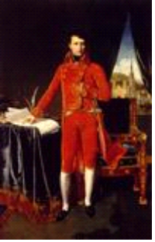
Signed in 1802, the Peace of Amiens marked the end of the French Revolutionary War. For the British, it brought respite from con?ict abroad. As part of the peace treaty, Britain, isolated from her allies, agreed to return recent territorial conquests to France, Spain and Holland. These terms were heavily resented and the British, worried about Napoleon’s plans, refused to withdraw from Malta. Peace boosted First Consul Bonaparte's popularity and gave him the opportunity to begin internal legal, economic and educational reforms. Undermining the spirit of Amiens, he continued to strengthen his position in Italy, invaded Switzerland and stopped British trade in the continental ports that he controlled.

1803 Renewal of war with France
1804 Napoleon First Emperor
1805 Napoleon defeated Russo- Austrian army at Austerlitz
1809 Peninsular War Wellesley defeated French at Oporto and made Duke of Wellington.
Josephine divorced
1811 George III insane, Prince Regent
1812 Napoleon in Moscow
1814 Napoleon abdicated and went to Elba
1815 Napoleon in France again. June 18th Battle of Waterloo. Napoleon banished to St Helena.
NOTES ON PARTICULAR EVENTS.
1832. Death of Stephen Day. His home, Cove Cottage, built in 1830, was one of the first built in 1830 and he was the mason at Steephill Castle.
General Don, at Parkhurst and his visit to The Tap at the New Inn when surveying for the defence of the Isle of Wight. In 1815 General Don went to Jersey and surveyed the manpower available in the event of a French invasion and the his Militia Census predates the British Census of 1841.
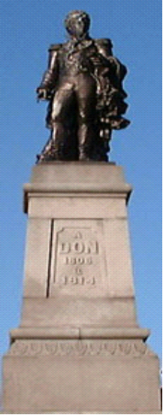
Monument to General Don in Jersey
St Lawrence Shute was reduced in steepness by Sir Richard Worsley using a company of Cornish miners stationed on the Island
The Appuldurcombe Bell was used in St Lawrence parish Church.
In St Lawrence Sea Cottage was built by Sir Richard as his marine villa and he lived there after his infamous law-suit
Sir Richard Worsley died August 8th 1805. There is a print of a battery of cannon at Sir Richard’s Cove by George Brannon. Sir Richard Worsley’s estates were inherited by his niece, Henrietta and her husband Charles Anderson Pelham, Lord Yarborough (2nd. Baronet and 1st. Earl ) of Brocklesby Hall in Lincolnshire.
His son, Charles Anderson Pelham succeed him in 1857 as the 2nd.Earl.
The second son The Hon Dudley Pelham,R.N. built a house St Lawrence Cottage (then Southwold now Lisle Combe) next door to the east on the site of Reynold’s cott. St Lawrence Coastguard Station, 5 revenue men came to stay at Reynold`s Cottage. It became the Hon Mrs Pelham-Sinclair`s house
Smugglers.

In 1823 The Duke, Adulphus Frederick of Cambridge (11th child of George III) and his wife, Duchess, Augusta of Heese-Kasels visited Marine Cottage
Frederick Augustus , Duke of York visited St Lawrence in 1827
In !832 Edward Augustus and his wife Victoria of Saxe-Coberg, Duke and Duchess of Kent and their daughter Princess Victoria visited Lord Yarborough
Earl of Yarborough was made the first Commodore of the Royal Yacht Squadron in 1815
The New Inn ( now Hillside) was built in 1800. Mrs Groves from the St Lawrence Inn was the licensee.
The Tap was an ale house attached to the Inn ( picture from Freeling.)
Mr Thomas Bowdler (Dr) at St .Boniface Cottage. He wrote ‘The Family Shakespeare’, “bowdlerizing it”
Lord Yarborough’s signal station on St Boniface Down relayed messages to Portsmouth.
Irish wherries.
A decked sailing vessel of shallow draft.
Dutch doggers.
A short wide-beamed Dutch craft, often used as a fishing vessel or, in the 17th and 18th centuries, a privateer due to its
manoeuvrability. Fitted with a ketch rig or variations thereof. Used extensively in the North Sea.
Lt. Col. William Hill, Lord of the Manor, of St Boniface House, shot himself. in 1783 (buried in Shanklin). He had married Elizabeth Popham of Shanklin His son Lt. Col. Charles Fitzmaurice Hill married Margaret Buckley and when he died in.1811 and their daughter Rosa (married to James White) inherited the Bonchurch estates and their son Charles Popham Hill inherited the Ventnor estates.
The 6th Earl of Dysart’s (Hon Wilbraham Tollemache ) Cottage purchased in 1780 from Sir Hans Stanley’s sister
Duke of Bedford at St Boniface House. Other tenants: Sgt Adams and family`.
1841 Lady Montague, and the Earl of Sandwich. See Whitehead p. 125.
1828 Steephill Castle .built on the site of Earl of Dysart’s Cottage by Mr Hamborough, who purchased it from Lady Louisa Manners, Earl of Dysart’s sister
John Hamborough.
Governor Stanley cut his throat.1844.
Governor Hans Stanley.
The melancholy, sable-suited figure whose portrait, again by Reynolds, is next in the display [ at Carisbrooke Castle in 1974 ], is hans stanley (1764-1767 and 1770-1780), the first since Girling to be without any title, military or civil, except that of his office. A Hampshire man, from Paultons, near Ower, his career lay in politics and diplomacy. A Member of Parliament for the greater part of his career, he was also for several years one of the Lords of the Admiralty, Charge d'Affaires in Paris, Privy Councillor, Cofferer of the Household, a scholar who left manuscripts on classical subjects, he was among the first Trustees of the Sloane and British Museums, and an intimate of Helvetius. A memory of him lingers in the Island, where he built Steephill Cottage, near Ventnor.
A bachelor to the end of his days, he never laughed, and was described as awkward, ungracious and eccentric, although Lady Hervey, who knew him, thought him 'very ingenious, sensible, knowing, conversible . . . His melancholy in the end overtook him, and in the gardens at Althorp, one day in 1780, he resolved his inner conflicts by cutting his throat.
From : Lords, Captains and Governors of the Isle of Wight. D.O.E. 1974
.See Notes on suicide and its prevalence at this time.
Death of Sterling at ‘Hillside’, the New Inn suffering from tuberculosis.
Ventnor Farm 1847 is the thatched house in the Grove, north of St Catherine’s Church
Lady Frances Tollemache, was the sister of Earl of Dysart and lived in the Farm. See Whitehead See Garle p. 42
Bathing machines in Ventnor Cove: see Whitehead p. 126. Used by the Duke of Bedford’s family, 1813-14. Started by Morgan, the Shoemaker not Bull the publican.
1799 Landslip at Chale, Pitlands. See account in old travelers’ tales
1819 East end landslip.
1799 ? 1798 Wreck of the ‘Henry Addington’ a homeward bound East Indiaman, ran aground in a fog at Bembridge. See Garle Appendix xxii and Collyer p.xxii
? Alpha Villa
1820 Russian shipwreck. Mr Holford of Niton Undercliffe gave relief .
Michael Morey the murderer, see Rooks and Ravens
Sir Richard’s Vineyard, The Vintner was John Julin, 1793-1808. 7000 vines on 2½ acres. See Warner ( The Bishopric …)
Karenhapuch Newnham and her lucky escape after falling over the cliff
The Little George.
Macketts of Bonchurch..were a family of farmers
1835. St Lawrence church. The well known poem by Old John. See Whitehead p. 199.

The Royal Family
Genealogical table.

James 1 m. Anne of Denmark.
I
________________________________________________

l I
Charles I 1625-1649. Elizabeth of Bohemia, The Winter Queen
m.Henrietta Maria I 13 children
I

________________________________________________
I I I I I
Charles II. Mary Henrietta James II 1685-1688. Henrietta Anne, ‘Minette’ Sophia
1660-1685. m.William II m.Anne Hyde m Philip of Bourbon m.Ernest Augustus.
of Orange I Elector of Hanover
I had 13 children_____________ I

#13 was James Frederick Edward I
‘The Old Pretender’
m. Maria and their son, Charles Edward
was the Young Pretender, Bonnie Prince Charlie George I
See below*

William, III 1688-1702 m. & Mary, II. 1688-1694
whose sister Anne
Became queen, by arrangement, when William III died

Anne 1702-1714
m. George of Denmark
19children none survived.

* George I 1714-1727
m. Sophia Dorothea of Celle
I
George II !727-1760
m. Caroline of Ansbach.
I
Frederick
m. Augusta of Saxe-Gotha
I
George III 1760-1820.
m,.Charlotte of Mecklenberg-Streltz.
I
____________________________________________
I I I
George IV 1820-1830 William IV 1830-1837 Edward duke of Kent
m. Caroline of Brunswick- m. Adelaide of m. Victoria
Wolfenbuttel. Meiningen of Saxe-Coberg
I
Victoria, 1837-1901 m.Albert of Saxe-Coberg

In 1700 The little Duke of Gloucester, the last surviving child, of Queen Anne ,died.

The Electress, Sophia was declared next in line to the Throne. Act of Settlement 1701.

George Louis was Elector of Hanover and became George I in 1714.

George III suffered from porphyria, which caused his insanity..

George, Prince of Wales became the Prince Regent in 1811 and ruled for 9 years as George IV, from 1820. He married Maria FitzHerbert, but Parliament offered to pay his debts if he married Caroline of Brunswick which he did. He divorced her on George III`s death.
Their daughter, Charlotte, who married Leopold of Belgium, died in childbirth

William IV, George IV’s brother’, Sailor Bill’, was 69 when he succeeded to the throne.

The Children of George I.

1. George II
2. Sophia Dorothea married Frederick William of Prussia.

The Children of George II.

1. Frederick Louis, became Duke of Cornwall when his father succeeded to the throne.
2. Anne. She married William Prince of Orange.
3, Amelia Sophia Eleanor
4. Caroline Elizabeth.
5. George William.
6. William Augustus.
7. Mary.
8. Louisa.

The Children of George III. He married :? 1. Hannah Lightfoot 1759. Missing from Royal Archives.
2. Charlotte 1761 who had:

1. George IV m. 1 Maria FitzHerbert.
2 Caroline of Brunswick..

He was made Prince Regent in 1811.
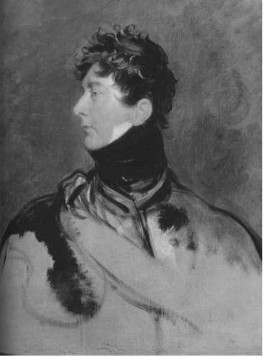

The Prince Regent in 1814.

2 Frederick Augustus, Duke of York, Albany and Ulster.1763-1827
m. Frederika of Prussia.
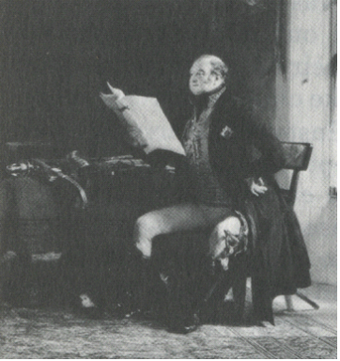

3. William IV m Queen Adelaide and 11 Illegitimate children by Dora Jordan.
4 . Charlotte Augusta m. Frederick of Wertenberg.
5. Edward Augustus, Duke of Kent, m. Victoria of Saxe-Coberg. She was married previously with 2 children.
His daughter was Queen Victoria.
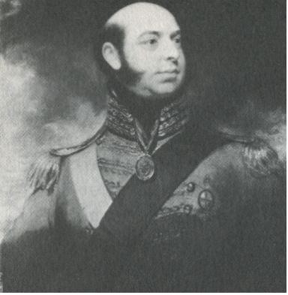

6 Augusta Sophia married Maj. Gen. Sir Brent Spencer.
7 Elizabeth m. Frederick Hesse-Hamberg
8 Ernest Augustus, Duke of Cumberland, Later King of Hanover, (Victoria couldn`t take this title because of Salic Law).) m. Frederika of Meckleberg Strelitz..
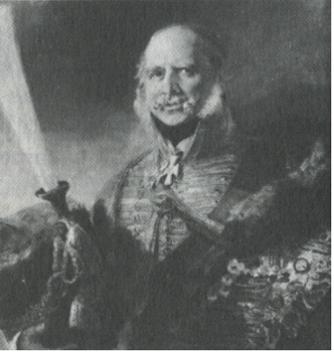

.9. Augustus Frederick, Duke of Sussex, m. A)Augusta Murray, Duchess of Sussex
B) Cecelia Gore nee Underwood.

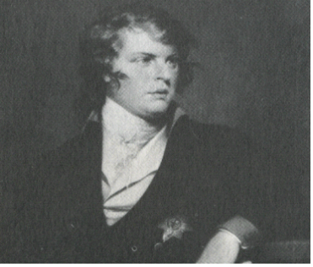

10. Adolphus Frederick, Duke of Cambridge m. Augusta of Hesse Kasels.

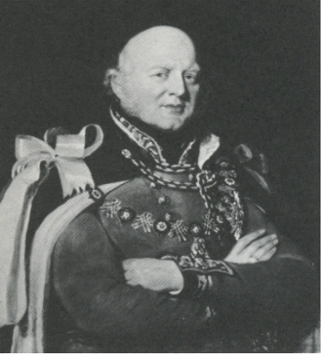

11. Mary m. her cousin William Frederick, Duke of Gloucester.Son of William Henry Duke of Gloucester , son of George II.
12 Sophia Matilda, m. General Thomas Garth.
13 Octavius, 1789-93 died age 4.
14 Alfred, died age 2.
15 Amelia, m. Charles Fitzroy, died of erysipelis 1810.

Children of George IV.
Married:
1, Marie Anne Smyth
2. Caroline, daughter of Charles of Brunswick-Wolfenbuttel

The only surviving child of William IV, ( brother of George IV), who married Queen Adelaide, daughter of George of Saxe-Meiningen was:
- Charlotte Augusta who married Prince Leopold of Saxe-Coberg.

Mrs Groves Inn at Steephill
After we arrived at the Inn at a Steephill we found no bed to receive us, for different parties had already taken possession of those that were in the house; in addition to this we were obliged to put up with such homely fare has offered asked in the tap room, and here we solaced ourselves. After that task we had conversation of those that composed the vile group of the taproom. After some persuasion the mistress of the house furnished us with a bed in the kitchen, but we found it necessary to fill up the long and tedious vacancy from 6 o'clock until 12, before we were permitted to close our eyes; fortunately a party of Welch soldiers were stationed at the house and they amused us with singing several of their provincial songs with true Cambrian spirit.
From Ped Tour

