Notes on Castlehaven.

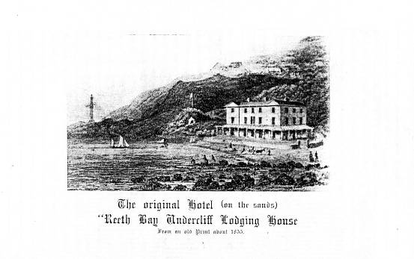

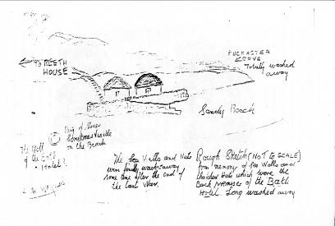

Sketch by George R. Haynes.
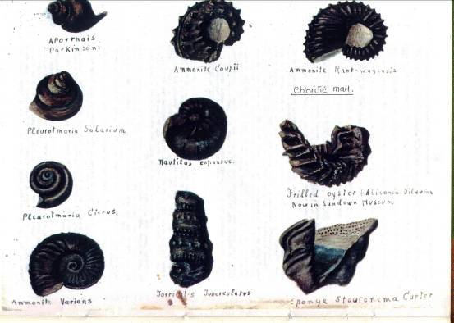

Fossils in Chloritic Marl at Castlehaven found and drawn by George Haynes.
.
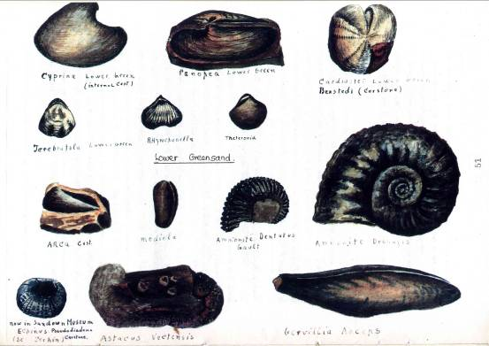

Fossils in the Lower Greensand at Castlehaven found and drawn by George Haynes

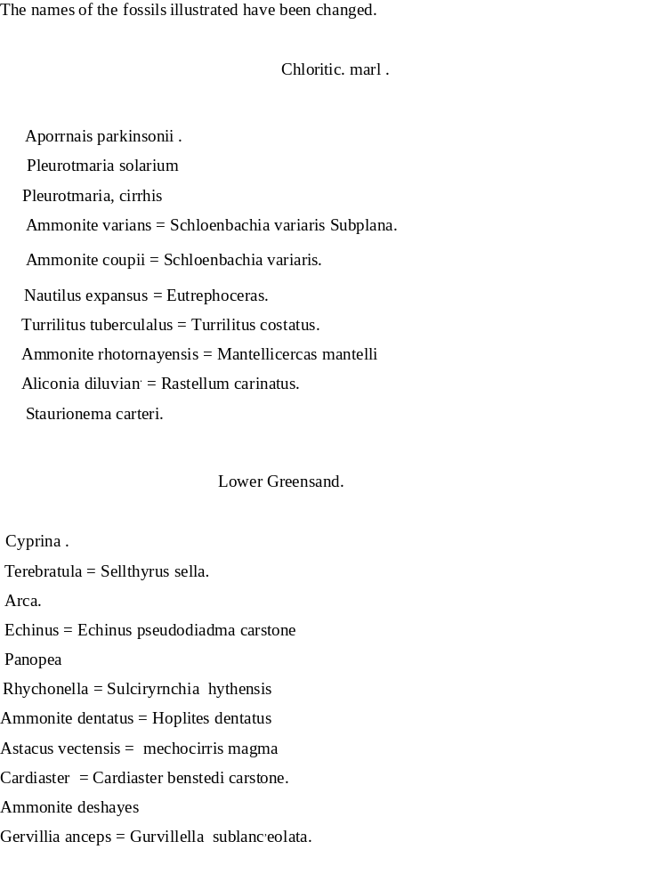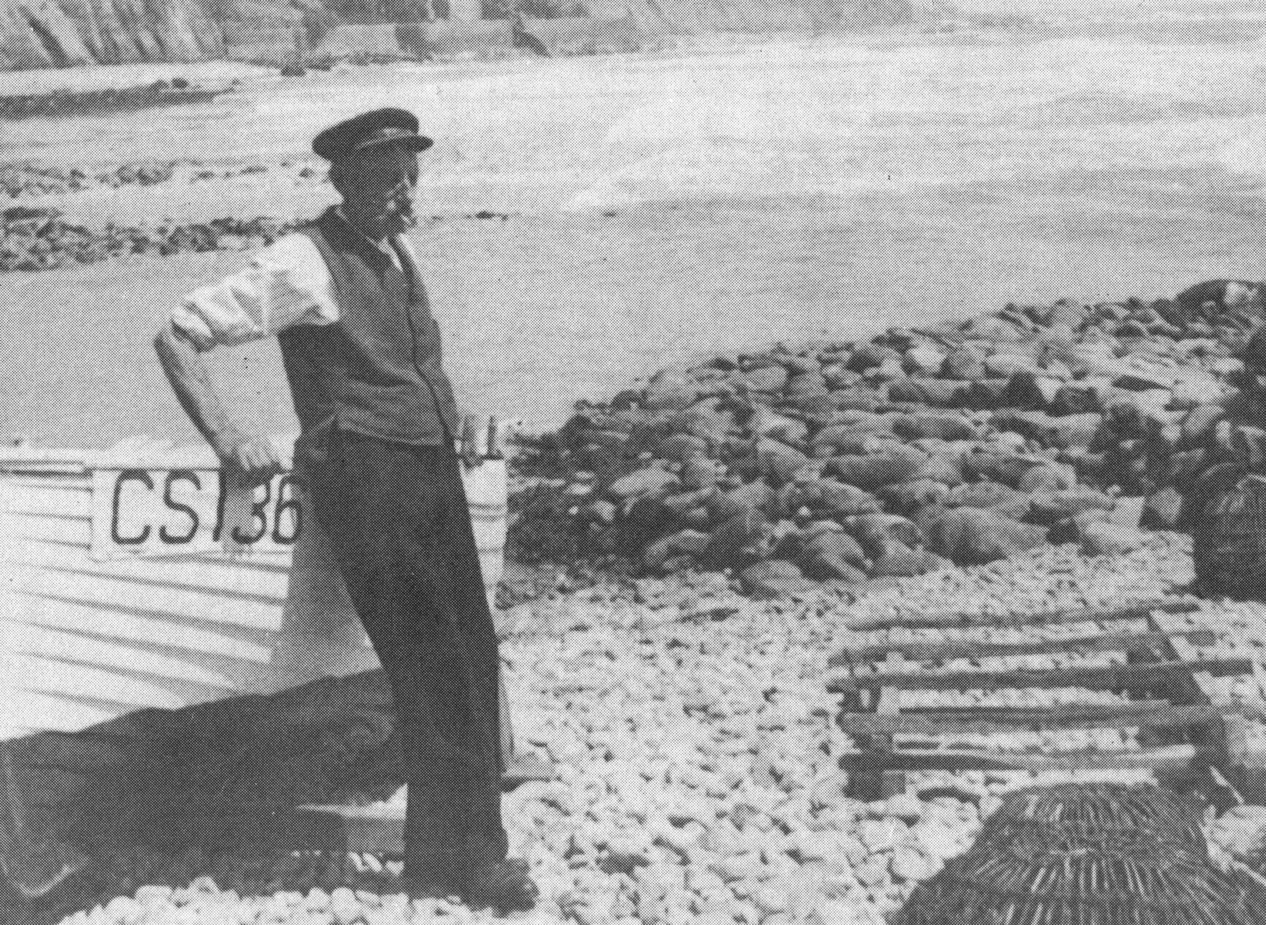

George Haynes, Senior

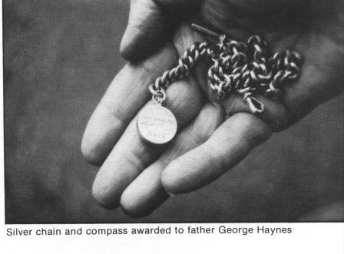
Silver chain and compass presented to George Haynes, senior, for bravery in saving a member of the crew of the shipwrecked ‘Jeune Benoni’ on the 18th. October 1891. The ship’s owners made the presentation. The compass and chain were stolen from a Ventnor home.
The story of George R. Haynes, entitled ‘It Used To Be Like This’, was published by the Isle of Wight Teachers’ Centre in 1984. It was this George that gave me his cousin’s notes and the other material just before he died.
For an account of this shipwreck see: ‘Shipwreck! Broken on the Wight’
by Ken Phillips. 1995. Pp. 32-34

