Sir John Cheke.

The most illustrious member of the family of, ‘ the Chekes of Mottistone’ (who originally
came from Whippingham) was Sir John Cheke, cousin of Sir Thomas Cheke of Mottistone..
He was born in Cambridge on June 16th 1514. He was educated at St John’s College Cambridge
and in 1554, became Professor of Greek at the University. Milton wrote,” He taught Cambridge and
King Edward, Greek.” In 1554 he was called to be Tutor to Prince Edward in Latin and Greek and
was knighted by his pupil when he became King Edward VI. King Edward named Lady Jane Grey
as his successor and Sir John supported her cause, becoming Secretary of State for the nine days
of her reign. However, Queen Mary sent him to the Tower of London. He obtained a pardon and
licence to travel but between Brussels and Antwerp he was seized on the orders of King Phillip II
of Spain and sent back to the Tower of London. He was given the option to “turn (to Catholicism)
or burn” and under the threat of cruel torture “he fell” in 1556. He became depressed and died,
aged 43, in 1557.

Checklist no. 1.

De orbitu doctissimi et Sanctissimi Theologii doct. Mart. Bucrei Regii in Celeberrima Cant Academia apud Anglos publice Sacrarum literarum Praelectoris Epistolae duae etc. Lond.
Sir John Cheke.
R. Wolfius 1551

See Boucher James *, Letters, Volume 1, pp. 535-9.

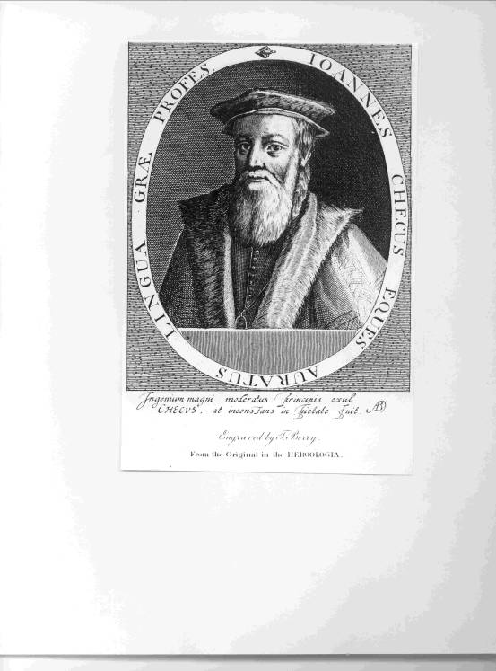

Back to index.

