The Sandrock Chalybeate Spring.
Dr Alan Champion.
- Dr Thomas Laurence Waterworth, a physician from Newport, having heard of the healing properties of the aluminous †chalybeate * water mentioned in Worsley’s Isle of Wight History, explored the area in 1807 and having found the spring ¹ developed it. He was granted a lease for lives by Charles Anderson Pelham the then Lord of the Manor of Chale and later by Michael Hoy, Esq.. He built a grotto for visitors to take the water. Dr Lemprière of the Army Depot Hospital at Parkhurst described the finding of the spring and its medicinal properties in 1811 ² ³ ⁴ ⁵ ⁶
Access to the spring was from the road from Niton Undercliff to Blackgang and the Royal Sandrock Hotel was built near the Niton Undercliff end of the road. The business of selling the water at the Dispensary declined and the Spring closed to the public in 1860. The last remnants of the grotto were lost in a landslip in 1958.The house was the home of the Livesay family but it succumbed to a further landslip in 1978.

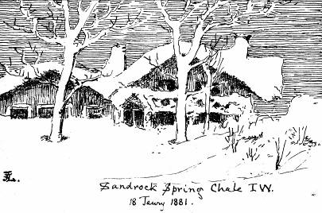

† aluminous i.e. a solution containing alum. An alum is a compound double salt of the general formula
R’(SO₄)R’’’(SO₄)² 24 H₂O, where R’ is a monovalent metal or radical e.g. sodium, potassium or ammonium and R ’’’ is an atom of a trivalent metal e.g. iron or aluminium.
* chalybeate from the Greek Χαλνβις –iron, from Chalybes in Asia Minor renowned for its workers’ skill in iron work. Meaning, impregnated or flavoured with iron.

1. Dr T L Waterworth. Letter to the Medical Profession as to the water at Chale. 1817. He was a Physician to the Army at Parkhurst, Isle of Wight .He has a memorial at Chale Church.
^{2. Island Chines.} Isle of Wight County Council. 1998.
3. Lemprière, W., M.D. Report on the Medicinal Properties of Aluminous Chalybeate Water recently discovered at Sandrock in the Parish of Chale in the Isle of Wight : Newport, I.O.W. 1813.
Dr William Lemprière was a traveller and medical writer. He joined the Army Medical Service and wrote books on Morocco and Jamaica. He was stationed at the Army Depot in Newport, Isle of Wight
^{4. Mew, F. Back of Wight.}
5. Marcet, Alexander. A Chemical Account of an Aluminous Chalybeate Spring in the Isle of Wight. Transactions of the Geological Society, 1819
Dr Marcet was a physician at Guy’s Hospital.
6. Scudamore, C. .A Chemical and Medical Report on the Properties of Mineral Waters… etc, including the Isle of Wight.1820. 2nd ed. 1833.
Sir Charles Scudamore, M.D., M.R.C.P. Physician to Guy’s and St Thomas Hospitals.

