The Countess of Blessington.

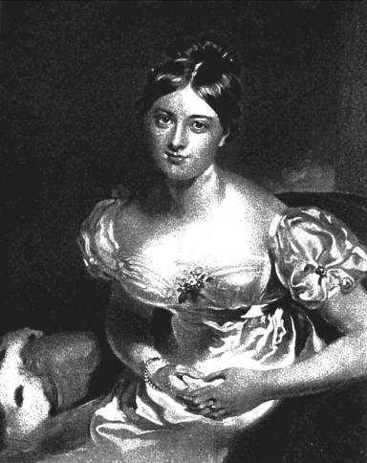

1822. A tour in the Isle of Wight, in the Autumn of 1820.
‘Currente Calamo’.
Nomme de Plume of Marguerite Gardiner, 1789-1849, Countess of Blessington.
She also wrote as Margaret Power.( her maiden name ) First married, when she was 15 to Capt. Maurice Farmer, who died in 1817. She then married Charles John Gardiner, the first Earl Blessington, in 1818.
See ‘ A Memoir of the literary life and correspondence of the Countess of Blessington, Dr Madden, 1840 and The Most Gorgeous Lady Blessington, J Fitzgerald Molloy, 1896 for biographical details.

Introduction.
TO THE READER
THE Tour which this volume contains, was written without any idea of its ever being perused,
save by the partner of it; but having been lent to a friend, whose partiality to the author led him
to attach a value to it, she was induced to have a few copies distributed among those whom
friendship or acquaintance might render willing to receive a memorial of the respect and regard of
THE AUTHOR.

St. James’s Square,
July 6th, 1822.
84 pages.
Checklist No.373.

