Goss: St Catherine’s Oratory.

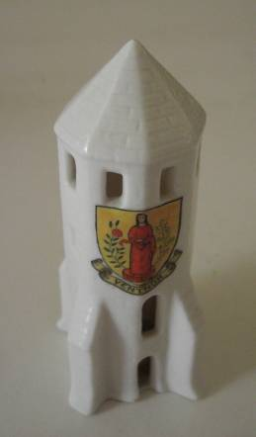

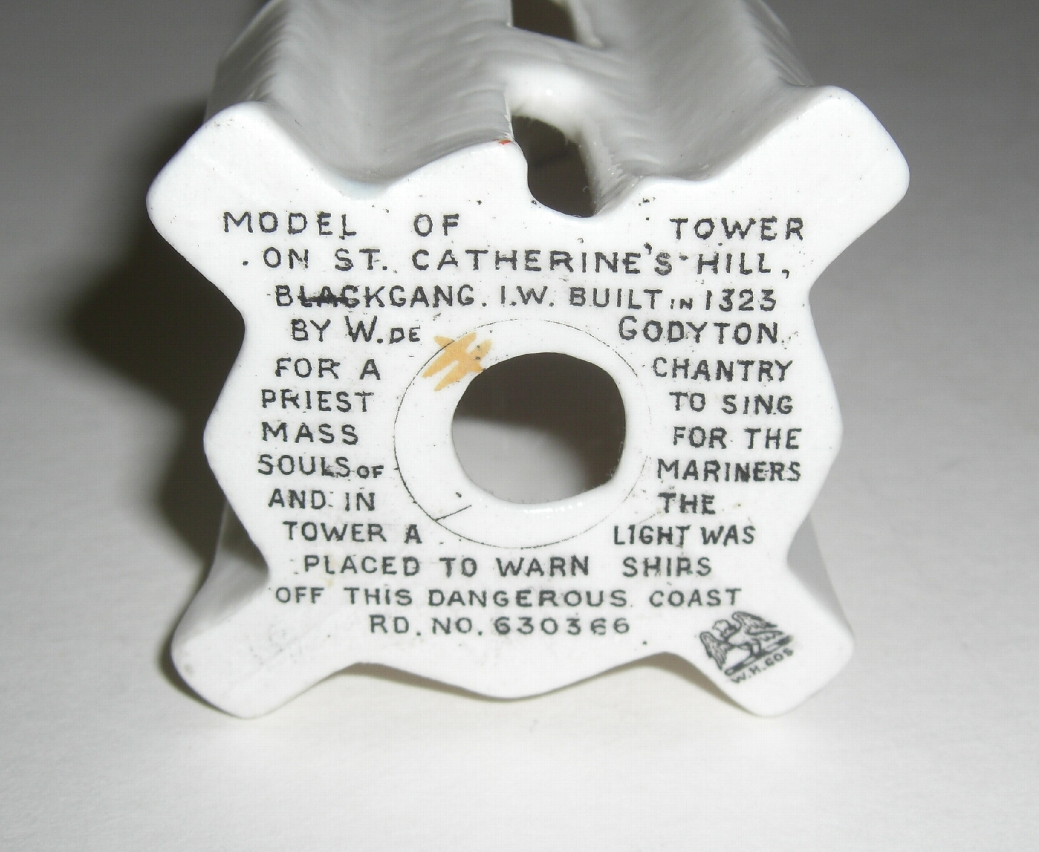

This Goss China piece was made about 1928. It was photographed with the kind permission of its owner, Steve Milligan of Ventnor.

Model of the tower on St Catherine’s hill , Blackgang. It was built in 1333by W. de Godyton for a chantry priestto sing mass for thre souls of mariners and in the tower a light was placed to warn ships of f this dangerous coast .
Rd. no. 630 366.

