The Ledger Book of Newport.

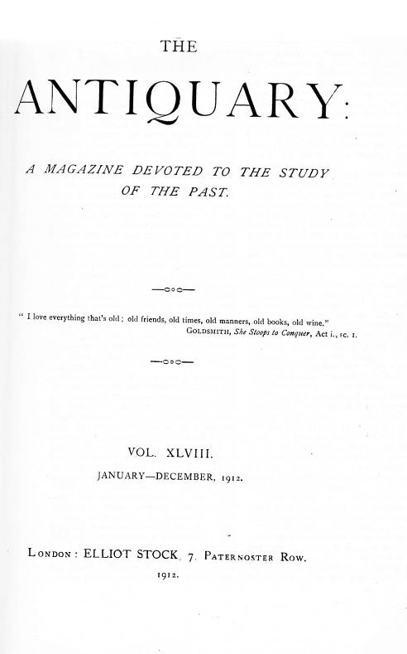
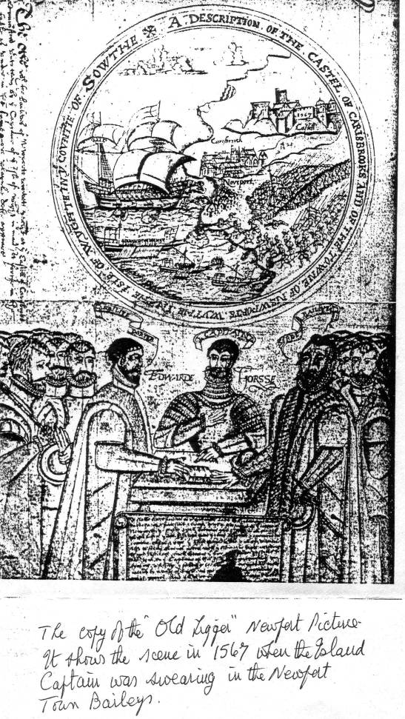
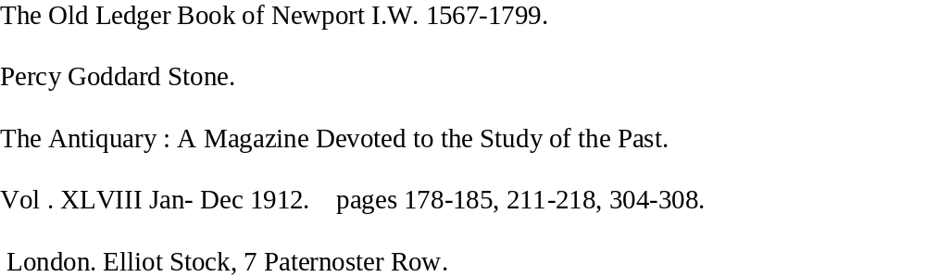

178

The Olde Ledger Booke of Newport

I.W. 1567-1799.

.The Ledger Book, or " old Ligger," as it is written in contemporary records, is, with the exception of the Charters, the most interesting and valuable of the muniments in the possession of the Corporation of Newport. It owes its origin to the laudably conservative action of the then bailiffs of that ancient borough, who, in 1567, caused all the charters and documents of interest or importance then in their possession to be copied into this ledger book, which they had had made for this express purpose. From time to time their successors in office followed their praiseworthy example by continuing the entry of all matters of interest connected with the town in this book, which thus became a really valuable record of the doings of the Corporation from the reign of Elizabeth to that of George III. The later entries, however, seem to have been somewhat erratic — written haphazard on any page that came handy, regardless alike of order or date.
The book itself, bound in sheepskin and measuring 15½ inches by 11 inches, contains 201 folios written both sides, or, according to present-day pagination, 402 pages. The paper of which it is composed is somewhat worn at the edges and soiled with damp, but is otherwise in fairly good condition. There has even been an attempt at illustration, which, however, did not get beyond a somewhat vigorous delineation of an attack on Newport, the swearing in of the bailiffs before the Governor of the Island, the arms of Isabel of Forz, and an initial E taken from the Charter of Edward VI. and made to do duty for that of Elizabeth.
The late entries were all made by, or under the superintendence of, the Town Clerk, and when anything .considered of interest as bearing on municipal affairs occurred, it was ordered to be copied into the old Ledger to preserve it to posterity. On this account there are many entries identical with those found in the Court and Convocation Books. The work of the originators ends on folio 26, dorse, with a somewhat highflown peroration closing the view of the ancient records by the Lawday Jury October 25, 1568. These jurymen say- or are made to say—that " these deeds are truly recorded reposing and locking them up fast in the chest of this Ligger and as it were from hand to hand delivering them to our posterity for their better memory and understanding safekeeping maintenance; and defence of the rights Liberties and Commonweal of this the Queen's Majesty's town borough of Newport."
On February 14, 1645, this volume of civic record was sent up to London for Henry Worsley, the surviving member for Newport after the death of Lord Falkland at Newbury, 1643, owing to a question about the election of a Recorder. Before it left the hands of the Town Clerk, he, in the presence of the Mayor, solemnly counted the folios make sure the book was not tampered with during its sojourn amid the dangers of the metropolis.
The book opens with the preface:”The Contents of this book are gatherid out of diverse old auntient Recordes to ... together in order as foloweth by the industryl and laborious travayle of Willm Porter and John Serle baylives of Newport within the Wight in the Comitie of Sutht . . bailiweek. Ano nono Regine Elizebeth 1567 and endinge ano decimo RR Eliz.1569
“Christo duce et auspice Christo”
Then follows on the same page:
"The hole Kynges Sylver called the tenthes Fyftenes of the borowe of Newporte ys and ever hathe ben .... ovjl: xis: viijd. And the halfe thereof ys . . . iijl: vs. xd.
On the back of the folio starts a list of bayliffs and constables from 1556 to1 676, occupying eleven pages and of great local;
interest. Then follow their several oaths, that of the bailiffs evidently dating from the time of Philip and Mary.
“The baylies othe yerelie to be ministred at the Castell of Caresbrooke Captayne of the Isle in forme folowinge
" Ye shall be trewe baylies to the King and Queene and to their heires and successors and trewlie paie the ffe farme of the Newporte for this yere Ye shall be equal between p'tie and p'tie in all plaintes pleited before youe : Therupon give trewe judgement and execution. Toe trewlie observe and keape the assise of bredde and ale and all other victualls. Also to see the Kings Markett well and ordinatlie kept accordinge to good constience. as well betwene the bier as ye seller. Ye shall be obedient to ye Captaine of ye Isle aidinge counselinge comfortinge in resistinge and subduinge the Kings ennemies w^{ch} wolde intend to invade this Isle, as ye ought to doe accordinge to your powers. And all other things to doe wch appteinethe to a trewe baylies to doe for the tyme yt ye shall occupie the office of the newe baylie of ye towne »of Newporte. So helpe youe God and holie doue and the contents of this sacred booke."
A truly comprehensive oath setting forth the duties of a bailiff of the Tudor period.
On folio 7 is an extract from “Kirby’s Quest" referring to the Forest of Parkhurst and the right of the Manor of Alvington to
pasture therein, "taken," the translation runs, "on the Wensdaie y^{e} Eve of the Nativitie of o^{r} blessed Ladye in the Isle of Wight the xxxviij yere of the Reigne of Edward the thirde before John Kyrkeby, John Geberd and others."
Then follows the inspeximus* of the several Charters by Queen
Elizabeth, with, at the end, the drawings before mentioned of the attack on Newport and the swearing in of the baillifs and the arms of Isabel of Forz.,underneath, a somewhat unreliable pedigree of that ladysetting forth ” Wiim Bastarde conquered England and had one Willrn Osborney his marshall the whiche conquered at that p[rese]ntes the He of Wighte and the said Willm Bastarde did make ye said Willm the sonne of Osborney Comes of harteford and the sayd Willm the sonne of Osborney had two sonnes Jhon
and Richard that died leavi[n]g their father after
*The first word of ancient charters in England, confirming a grant made by a former king; hence, a royal grant.
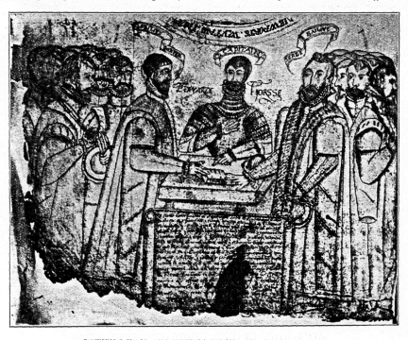
SWEARING-IN OK THE BAILlFFS BEFORE SIR EDWARD HASEY. (From the Newport, I.W., Ledger Book, fol. 5, dorso.)

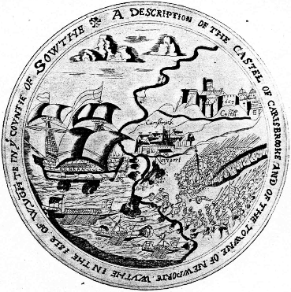
THE ATTACK ON THE ISLE OF WIGHT.
(From pen-and-ink drawing made in 1567, in the Newport, I.W., Ledger Book.

after whos deaths & after the death of their father the inheritance aforesaid descended to Richard de Ryvers, Nepos or nevewe of the forsaid Willm sonne of Osborney then beinge comes of Exceter of the whiche Richard came Bawldewyne his sonne and the sayd Bawldewyne died w'howte Issue so that ye same descended to Isabell his sister etc. . . ."
Needless to say, William Fitzosbern did not conquer the Isle of Wight, but was granted it by the Conqueror, and his sons were William and Roger, who both outlived him. We have no evidence that Richard de Redvers was of his kin, and the de Redvers pedigree has an alarming hiatus of four generations.The whole was copied by the.worthy bailiffs from a memorandum in the Cartulary of Carisbrooke Priory, and had to do duty for more reliable genealogical information. On the back of folio 9 is an extract from the Inquisition of Quo Warranto taken before Solomon of Rochester and the Justices Itinerant at Winchester on the octave of St. Martin, 8-9 Ed. I., followed by the Charter of Queen Elizabeth and confirmation of the borough's privileges Edward VI. An important entry in the Custumary of the town of Newport, by which we learn that a cart with bread paid a due of one penny, while a horse-load of the same commodity was only amerced in half that sum, identical with that on a quartern of wheat. A difficult due to collect must been that of 4d. "of ev^{r}y toune y^{t} passeth y^{e} cost of Englad."
From every bale of pepper, ginger, sedwell comell, galigale, mace, cloves, and basil the bailiffs took a pound, and bale of almonds, cummin, or liquorice 2 d.

181
The importation of a hawberk and habergeon cost the importer but the same sum. Returned empties were even taxed, a “voyde toune or a voyde pipe sent owghte of ye toune " costing the sender a penny, and yet a barrel of cider could enter for 2d. and a pipe of ale for a penny !—the latter the same due as on a " carte lode of plaist' of parys." Every porker, whether arriving by land or water, had to pay a halfpenny, and every " sacke of wull of England " 4d., while a Spanish woolsack—presumably inferior—paid but half. A bale of “cord-wayne," or Spanish leather, paid 4d., Irish cloth 2d., and English cloth a penny. No ship could anchor in the haven without paying an anchorage due of 2d. The imported furs were sable, marten, miniver, squirrel, hare, rabbit, fox, and cat. The fish: salmon (fresh and salt), porpoise, herrings (white and red), eels, stockfish, mackerel, haddock, lampreys, sturgeon, and sprats. The fruit: figs, raisins, nuts, apples, and pears. A person crossing to the mainland had to pay a due of 2d., and, if mounted, three halfpence more; and for every score of lambs " sold over ye water" there was a * charge of 3d. Sea-coal—" coles owght of ye sea"—was taxed a farthing a quarter, and a cart-load of charcoal double that amount.Of commodities not in the list a charge was finade of " a peny of every noble viz iijd of the pounde according to ye laues of ye realme for petit custom."
The account of the lawday held in 1462 occupies four pages, and is interesting read-". It immediately follows the Custumary,
and is headed: " Newporte. The lawday holden there the eight daye of Octobre the second yere of the reigne of Kyng Edwarde iiijth.. in the tyme of Willm Bokett and Henry Pyper baylives. Thos. Casseford and Willm" Springe Constables there."
The jury having been sworn declare on oath that " these bythe and hathe benne the constitutions use and olde customes of this Towne yn tyme passed by the discrecons off joure olde ffaders and predecessours before the brynnynge and distruccon off the seid Towne* dewlie continued. . . ."—namely,
*This refers to the burning of Newport by the French in August, 1377, which depopulated the town for two years.

that if anyone is elected bailiff, constable, churchwarden, or warden of the Common Box, and refuse to serve, he shall be fined 6s. 8d. or lose his freedom. That the Town Council is to consist of the bailiffs, constables, and eight chief burgesses who are to administer the law " withowt ony contradiccon," and that no court shall be held in the borough without the attendance of the bailiffs " w^{th} thre or ffoure Dyscrete Burger." That no man can be a burgess unless he hold a "place"* and lives in the town. That no burgess is to sell or buy with any stranger unless he brings him to the bailiff to pay his due. An offence against the town officers is to be punished with a fine of 40s. No shipmaster may dispose of his cargo without licence, and no stranger may open a shop. People having carts are to lend them for Corporation business, such as repairing the quay or the streets. No one is allowed to fish in the Haven without licence, and, if a burgess, at the third offence to lose his freedom. Any " yangelor or yanglatryce, as oftyn tymes as they offende y^{m} trobelyng their nyghbours," have to " suffrey the jugement y^{n} the Cokyngstole," as well as pay a fine of 6s. 8d.—a summary method of dealing with a troublesome neighbour.
Oysters have always been cultivated on the northern mud flats and carefully preserved. No one was allowed to "dragge for oysters wlyn the haven off the Town” without a licence from the bayliffs under penalty of 2s. 6d., and a licenced fisherman had to sell them in the market "a hundryd told by syx skore for ijd, and no derer." Great oysters gathered by hand for iiijd, and salt oysters for a .halfpenny. Every boat - owner had yearly to " gadre in the see at large, a bote ffull of ostryes called ffrye and ... put the seid ffrye yn the haven off the Town yn the sight off the bayllyfs or off thair sergeauntes " under penalty of 3s 6d. Oysters cheap and plentiful was evidently the Corporation motto.
It was unlawful to erect pigsties adjoining the "Kynggs Byghway," or to even drive swine through the streets of the borough. Keepers of disorderly houses were heavily
* These “places " were about ¼ acre plots, 240 in
number in 1262.

182
fined, and no one could appoint a beadle without licence from the bailiffs. -
The next entry is one of the most interesting in the book, and gives us an insight into the municipal life of the borough in Tudor times. It occupies three pages of closely written manuscript and is headed:
"Theis be the auncient usags and olde customes of the borowgh of Newport within y^{e},. Isle of Wight dewlie continued fro ye tyme y^{t} memorie of man is not to the contrarie."
It is divided into twenty-six " Items," and begins with the preliminaries to the election of the bailiffs the " Thursdaye precedinge ye Sonday nexte before the Feast of St. Michell th' archangell," when the bailiffs and chief burgesses left the Guildhall at ten in the morning for the Church of St. Thomas, " there to yelde and receve ye chardg of the olde officers and Shortlie after to p'cede to ye eleccon of newe govners," first devoutly kneeling and asking God's assistance in the choice. This prayer ended, the last lawday jury stood forth, and the old bailiffs bareheaded, their caps and maces in their hands, "w^{th} woordes of submisscon rendereth the accompte of their Bailieweeke," and handed their insignia to the foreman, who either blamed or commended them "accordinge to ther deservings ye hole yere p'ceding." They then resumed their offices, conditionally, till noon Michaelmas Day. The constables did likewise, and, the ceremony finished, all adjourned to " ye yowng Bailives howse to dynner, and there maketh merrie." After dinner the whole company, but without the bailiffs, again adjourned to the church to choose new officers, dividing themselves into two bodies. “They y^{t} hath born ye cheef office into ye chauncell as ye higher roome, and ye residewe into ye Bodie of y^{e} Churche as ye lower roome. Then do the ye elder co'panye ley their heddes together, and after good advise and deliberacon taken, writteth owt two of ye elder co'panies names yn a little Tickett or Scrowle of paper whome they, betwene them selffs, estemcth moste worthieste to supplie ye roome of ye Elder Baylive ye yere ensuinge, Sendinge hit downe by the Steward, sworne, to ye yownger Companie, to ye intent y^{t} every of them sholde sette a sevrall note or prycke upon his hedde whom they thowght moste worthiest for ministringe of Justice to be advaunced to ye roome of ye Elder Baylie."
The elder bailiff being elected by majority of pricks, the younger was next elected “by voyces onlye." The election over, a procession was formed, the sergeants going before with the maces, " ye elder olde baylie goinge on ye right hand accompanied with ye elder newe Baylive in ye lefte syde," and the junior bailiffs in like manner, the constables coming next "and all the Burgess folowing, Copples in their degree, and there [i.e. at the old bailiffs houses] maketh shortte drinckings, as with a peare or proyne, or such other leeke." The Sunday following, the old officers conducted the new to Carisbrook Castle, "there to receive their othes ministred unto them by the Lieutenant of the Isle accordinge to the forme prescribed before in this present book." The oath taken, the bailiffs and burgesses breakfasted " in ye Porter's Lodge w^{th} the porter of ye sayde Castle, wth Bred, drinck, rosted ribbs of Beefe, and garlicke," for which they paid according to their degree, and started home again in couples until they reached the market-place, where they separated. On Michaelmas Day at noon the old bailiffs sent the maces by their sergeants to the new magistrates, and so rendered up their office.
Breakfasts seemed much in vogue, the elder constable keeping one on the first lawday after Michaelmas, and the younger
"an other Breakfaste at ye second lawday abowght hocketyde," towards which each burgess contributed a penny, but the bailiffs went free. Towards the bailiffs' dinner the taverners of the borough had to supply " one Quarte of the Best claret or whight wyne at iiij principall tymes in the yere: y^{t} is to weete, upon Alhallow daye, Christms Daye, Ester Daye and Wittsondaye." The fishermen had also to contribute in kind. Every licensed dragger supplied each of the bailiffs yearly with two hundred "of the best haven oistres . . . halfe a hundred upon Alhallowe eve, halfe a hundred upon Christms eve, halfe a hundred upon Candlems Eve, and ditto hundred upon ye eve of th' annunciacon off our blessed ladie the Virgin Marie," as well as a draught of their fresh fish " when and as often as hit shall leeke the said bailives

183
or their deputies to walke downe and choose their said Drafte"—a custom with a somewhat wide margin. On Easter Day the bailiffs and burgesses received the Sacrament at the hands of the Vicar of Carisbrooke, who dined with the chief bailiff, and in semi-state "walked abrode into the fieldes for their solace, necessary and pleasure; and so with comendable talke passinge awaye the afternoone, returneth in dewe season to "eveninge prayer. The ^{wch} prayer ended, the Vicar . . . inviteth ye said Bailives and their Bretherne to drinck wth him his wyne —Comonlie called ye Vicar's wyne—wth whom they goeth all to drinckinge." The next item, as it describes a May Day merrymaking of the period, I venture to give in extenso. " The Satydaie after Maie daie, the Custome is and hath ben, tyme owt of mynde, yt ye Bailives for ye tyme beinge sholde yerely appoynte a Lorde to ride with a mynstrell and a Vice a Bowght the Towne, a pretie companie of yowthe folowinge them, wch steing at every Burgs dore, warneth every of them to attend upon ye said Bailieves att ye wood ovis of Parckhurst* the nexte morninge to fetche home maye, and to observe ye olde custome and usadge of ye towne, upon payne of every one making defaulte and not they there present before the Sonne risinge to loose a greene goose and a gallon of wyne. The maner whereof in forme foloweth. When ye sayd Bailives wth their co'panie cnburgess be come to ye wood ovis, yere cometh forthe ye keepers of fforest meetinge and salutinge them, and offeringe smawle greene bowes to every of them, signifienge thereby y^{t} ye said Bailives and Coburgs hathe free com men of pasture † for all maner their livinge things in all ye Laundes of P'khurste unto ye said wood ovis, for ever, accordinge to their charter. After ye Bowes so dellivered to ye Surges presentlie—accordinge to auncient custome—ye commen people of the towne entereth into Parkhtirst woode wth their hatchetts, sarpes, and other edge tooles, cut-tinge greene bowes to refresh ye streets, placinge them at their dores to give a com-

* Sir John Oglander, 1595-1648, says this place was not known in his time, " but it wase ye edge of -ye wood where ye hill beginneth to ryse as soon as you ar on hoonnye hill. . . ."
†By charters of Rich, de Redvers and Isabel of Forz.

odious and pleasant umbrage to yre howses and comfort to ye people passinge bie. - And assone as ye said commen people ar spedde competentlie wth greene bowes, they returne •home in marchinge arraye—the commoners before, the keapers folowinge them; nexte ye minstrell, vice, and moriss dancers ; after ye Sergeants with their maces; then the Bailives and Coburg's cooples in their degree : ye gounes and chambers goinge off after a triumphant maner, untill they come to ye come markett, where they sheweth suche pastyme as ye leeke to make; and after castinge themselffs in a ringe all departeth, except only ye Burgess wch wth the keepers bringethe ye Bailives home, where, of custome, ye keapers breaketh their faste prepared for them; eche of the Bailives and Burgess, with speede, preparinge them selffes to morninge prayer, and fro thence, with ther wifes, to ye olde bailives dynner. This use of cuttynge greene bowes indureth for ye holie days, eves, and mornynge only ye May moneth: and people of custome ought to goe but once a daye.* But sere and broke woode ye said inhabitants of ye towne hathe ben accustomed, time owte of mynd, to fetche home att their Backe with their pickards from ye woode aforesaid all ye yere longe, savinge only ye seme moneth; and also to have, by estimaceon, xxx acres of furzes and other fewell in ye said lawndes wthout ye said woode all tymes of ye yere withowt excepcon. The custome ys and hathe ben, time out of mynde after Dynner ye said Daie, ye Bailives wives wth their sisters ye coburg's wifes, orderlie in their degree, by cooples to walke forthe to Buggeberie for custome and pleasure onlye, ye lorde, ye moriss dauncers, ye mynstrell plainge before them wth other pastyme for ye daye prepared; and so to retorne in leek maner so[me]what before eveninge prayer to ye elder Bailives house where they Bancketeth and so repaireth to eveninge prayer, and fro thence to supper—passinge the hole daie in good companie, myrthe, and honest plesure."
A sound, old-fashioned English merrymaking. One can picture the civic procession winding its way up Hunny Hill in
* This privilege became so abused that in 1621 the custom had to be discontinued (fol 53 dorso.)

184

the grey of a May Day dawn, and being met by the forest keepers with their green boughs; its return with its load of greenery, headed by townspeople, minstrel, and morris dancers, to the accompaniment of much waste of gunpowder : the decking of the house doors with the fresh spring green ; the Corporation dinner and the after-dinner jaunt of the ladies to Bigbury, while their lords doubtless sat over their wine; the banquet and supper judiciously separated by evening prayer.
Then follows reference to the market to be held weekly on Saturdays; the annual fair in Pentecost week for " the space of iij hole daies viz mondaie tuesdaie and wensdaie "; and the lawday held at -Michaelmas and Lady Day.
The next two items have to do with the Courts. The Court of Pie Powder " kept yerely in the Sergeant's bowthe called ye Pavilion Coorte for and during ye time of ye said faire.'' The weekly Borough Court on Saturday “for the assize of Breadde and other victualls, and for other suites there entered or dependmge betweene partie and p[ar]tie"; and a Town Court to be held pro re nata. The bailiffs are to be coroners and clerks of the market, and " to have ye servinge of process wthin ye Borough." They are also to be centoners, or captains, of the town militia, with the constables as sergeants under them. " All and sing'ler the inhabitants '' are to be ready with clubs, bills, and halbenis " at evene ringe of ye watche bell ... to attend upon and swarme abowght the office forthwth for ye conser-vacon of the Queene's peace and ... for ye spedie helpe to be had to supprese foreine enemies tumults tier," etc., and they are to be free of all foreign service except repairs to the bulwarks where the chain stretched across the haven to defend the approach by water to the town.
The next three entries are, from their date, 1611, evidently out of place, the sequence being carried on by a " copie of the deed of Hunny Hill w^{c}h deed lieth in a little black box in the toune chest" on folio 19.
This refers to a fifteenth-century grant of land * to the north of the town, afterwards
*By Agnes, widow of John Erlsman, 10 Oct., x Hen. V granted to the bailiffs and burgesses thirty four acres of land on Hunnyhill at an annual rent of twenty pence.

given as an endowment to the Grammar School by the assistance of the Earl of Southampton—Captain of the Wight, 1603-1625—in 1619. On the back of the same folio, and extending to eleven pages, is the lengthy charter of James I., substituting for the bailiffs a Mayor, twenty-four burgesses, and a recorder, in 1608. Then follows "a rentall of y^{e} yerely rents of all & singler y^{e} lands pertaininge to the borowgh of Newport wthin the Isle of Wight revewed 24 October 1567" —a valuable entry of great local interest, establishing the position of many places referred to in the town records, now demolished. The whole rental amounts to £15 17s. 8d. On folio 26, dorso, is evidently the last entry of the original compilers, which may appropriately end this first part of the description of the" Old Ligger " :
" Newport. At the lawe daye holden there the xxvth. daie of October 1568 etc. ... in the tyme of Willm Newnam & Thorns Bracklie bailives Wm Thorns & John Kent constables there" — Thomas James and twenty - three other burgesses being sworn—" saieth y^{t} they have diligent-lie perused the Copie of ye tenthes and fyftens comenlie called yu Kings Silver of this borough, the Copie of ye extent of the forest, the Copie of the confirmacons, the Copie of the bailives of the yerelie taken before the Captaine of ye Isle at ye Castle of Carisbrooke, the Copie of ye petigree of good dame Isabell de Fortibus, the Copie of Pleyne pleis before ye rovinge Justices at U'ynton and the Copie of ye Charter, the Copie of the Princes Comandement under the Great Stale for ye tresve execucon of ye libties &: customes graunted in ye said Charter, the Copie of ye Customarie, the Copie of ye Constitutions, ye Copie of ye ancient usage & olde customes of the borough of Newport aforesaid & the copie of the rentall of the towne lands " etc. . . . and say these deeds are truly recorded " reposing & lockinge them upp fast in the chest of this Ligger & als hit were from hand to hand deliveringe thrm to owr postente for there better memorie & understanding safe-keaping mayntenance & defence of ye right Liberties & Comenwealth of this the Quenes Maty & borough of Newporte a forsaid

“Glorie be to Godde
“Honor to the Prince
“Goode to the Comenwealth.

211.
The Ledger Book of Newport, I.W. 1567-1799.
(continued from page 185.)
The " Industrie and laborious travayle " of the bailiffs Porter and Serle does not seem to have been followed up by their successors, for fifty years elapses before the next entry. The borough had meanwhile been converted into a " Mayor Town " and had received a new and extended Charter from James I. The accompanying plan shows the disposition of the town at that period, a disposition that has altered but little at the present day. The streets have neither changed their names or directions, and many of the old landmarks remain. When the grammar school was first established is uncertain, but in 1559 the Commissioners under Sir Francis Knollys appointed to report on the state of the Isle of Wight conveyed to the burgesses the wish that the property of the dissolved chantry should be appropriated "to the Salarie or stipend of some good lernid man to be a scholemaster to bring uppe yowthe in lerninge and virtewe." Some sort of school-house was in use by 1580, as entries occur in the Corporation Books for its repair in 1583-84. It was not, however, till 1614 that a new school-house was begun on the present site, and a general subscription was set on foot for its support; and the first entry in the Ledger Book after the half-century lapse refers to a dispute with the parishioners of Godshill as to a £100 endowment, which going to arbitration was, as usual, divided between the disputants—the Newport £50 going to Andrew James of Newport "for that hee the said Andrewe James hath alreadie laied out the saied some about the building of the said schoole in Newport" (dated September 4, 1617).
On the next folio are set out the oaths of the new Corporation: The Mayor, Constables, Serjeants, Burgesses, Steward, Attorney, and Chief Burgesses, and then follows one of those local disturbances so frequent in civic records. Sept. 21, 1620, the Chief Burgesses were solemnly assembled "to prick" for the new Mayor, when " Mr. Edward Waterton one of the foure-and-twentie cheefe Burgesses of the Burrough " snatched away the voting paper " out of the Towne Clercks hands before all the xxiiii. Chief Burgesses had pricked, by reason whereof the eleccon could not proceed," for which he was dismissed his burgesship. The next sixteen folios seem to have gone back in date, containing entries from 1580 to 1596, mostly comprising Corporation accounts, which may have been copied in later. From them we gather frequent presents of sugar and spice were made the Captain of the Wight; that a drum of the period cost 3s. to make and was worth i6s. when made, taking a: calf's skin for each end, two " houves hoops to fasten them, and a " lyne to sling it by; that a bull-ring was forged cost of a shilling, and thirteen pence paid for a licence to use it; that the town gun or "best pece " was carried down to the quay, shipped, across to Lepe, and taken to London, total carriage amounting to 3s. 2d.
Armada scare had begun. News of Spanish preparations had been brough the Wight in the January of 1584, and George Carey, the Captain, had written same month to Sir Francis Walsinghan point out the defenceless state of the isle It is probable, therefore, that the New: " brasse pece " with which every island parish was supplied—was sent to London to be made serviceable. The charge of 3d the accounts paid to “Sukerman for carriage up certeyne Callivers to the Castell" po to an appeal for arms to better defend Castle of Carisbrooke. References to town gun are frequent. In 1586 tenpe: was paid for bringing it from the Castle, a one Listeney had fourteen pence for mend: it; 30 lbs. of "Fyne corne powder" a 20 cases of "hayle shott" and a shillings worth of " twyne and olde Iron to put them " being supplied for ammunition. The gunners seem to have frequently been treated to drink, mostly on the occasions of the general musters, and in 1588 Messrs. Holstone and Bad, the local brewers, were paid nineteen shillings " for bere w^{ch} was carried out into ye feild when the Spannyards mat their attempt for Ingeland"—the only mention of the Great Armada.
To turn to more peaceful items in the same period, the clink called " Petie Judas” just off the north-east of the church and joining the shambles, was repaired, as was also the town gate, and the Audyett (Audit) House had two windows mended and coat of rough cast "in ye owtsyde." Thomas Sambrowe and Edward Wripam, the town whippers* were paid the small sum o one shilling each "for whipping of diverse p'sons at sondrey tymes," and John Warriner 2s. 4d. "for Keppinge of a sicke
*The fee for whipping a man seems to have been sixpence, women and children twopence cheaper.
213

man"—which seems to have been the Tudor idea of a cottage hospital, as it so frequently occurs in the accounts. Two quires of paper were bought at a cost of 8d. to make the Terrar book—i.e., of the value of Corporation property—and 123. was disbursed for a new "Coocking stoole " with an extra 33. for "Iron work abowte the same" A rogue, "one Willm Hills yt sayde he came out of Turkey "—the waster's excuse of the period to excite sympathy—was whipped at a cost of sixpence, and a grisly reminder occurs in the item " for a pole & speeke to sett up the traytors hedd . . . xvd." The cowherd, a public officer who looked after the cattle on Hunnyhill, was presented with a new horn of the value of 1s. 8d., and a new "Ligger Coorte booke " was purchased for 8s. An undesirable character, " Sibble Luckesse, for to rid her out of the towne " was paid is. 4d.,* and the town drummers
*Though to get rid of "Cromps boy" cost the Council just double.
214

were supplied with " ifij yards of grene cotton for their Coats" at a cost of ten shillings. The shooting butts were carefully kept up, and constant items for their repair * are entered. They stood to the south of the town " in Cossham," where the graveyard was later enclosed. A suit of uniform and a hat for '' Mr. Morton or Live Tennant" cost them the sum of £i xos. 8d., and silk for the town standard, or " Auncient," tenpence. The disbursement of half a crown " to the
Scoller wch was Frantick " significantly closes the list.
In the year 1584 Sir George Carey procured the revival of the representation of the boroughs of Newport, Yarmouth, and Newtown, in Parliament, as is set forth in a memorandum on folio 39: "That at the Speciall instance and procurement of Sir George Carey, Knyghte Marshall of her Maty moste
. * Items for "pales about the Butts"; 3 loads of "Hassocks aboute the Butts"; Turves cut and carried there; " Spikes about the sayd Buts.”

Isle of Wighte two burgesses were admitted into the highe Courte of Parlyamente holden at the Citie of Westmr the xxiiith dale of November in the xxviith yeare of the reigne of our moste graciouse and sovereigne Lady Elizabethe etc. ... for our towne of Newporte that is to saie Sr Arthur Bowcher Knighte and Edmonde Carey Esquier whereas ther was never Burgesses admitted in anie Courte of Parlyamente before that tyme during the memorie of man for the said towne. In concideracon whereof and for a memoriall that we Willm Jefferie then Bailliffe of the said towne and the Burgesses of the same do accounte our selves greatly to be bounden unto the said Sr George Carey have wth one assent & consente geven Full power and authoritie unto the said Sr George Carey to nominate one of the said Burgesses for us and in our names duringe the naturall liffe of the said Sr George Carey Knighte whose liffe God long preserve." Sir George got a substantial quid pro quo by nominating three members in his interest; indeed in 1601 he ordered the burgesses of Newtown to send him up the " wrytt with a blank wherein I may insert the names of such persons as I shall think fittest to discharge that deutie for your behoofe," thus claiming nomination of both members—an autocratic proceeding with a vengeance.
In 1604 by the influence of Sir George Carey at Court, where he had taken up his father's title of Lord Hunsdon, Newport was made into a “Mayor Town."

That the Corporation officers were determined the townspeople should have wholesome food is shown by the enactment of 1613 that outside butchers shall not sell their meat " in obscure places wheare yt cannot convenientlie be viewed; by reason wherof they divers time sell corrupt and unwholsom fleshe to divers of the Kings Maies liege people," but " shall stande therwth and shall shewe the same to sell in the highe streete right before or in the butchers shambles and not elswhere." They also carefully safeguarded the interests of the town and made stringent laws against outside trading. "Whereas," runs the order of January 20, 1612, "by experience it is found that the admittance of Strangers of severall trades and occupacons into this Towne hath ben and dailie is the ruin and decaye of the Native Inhabitants thereof, and such others as have served apprenticeships with them, wherby manie of the Towne have been and are enforced to seeke their livinge in other places and hardlie can ever recover anie estate to relieve them and their families. For redresse whereof it is agreed— that no manner of person ever hereafter shalbe permitted to use anie trade misterie or occupacon within the saide Towne but suche as shalbe admitted free men, without the allowance and consent of the Maior for the time beinge, Six Cheif Burgesses and foure at the least (if so many theare are) of that trade or occupacon that he professeth wch shall so desier to trade or dwell amongest them. . . ." Then follows the oath of the Freemen copied from the first page of the Convocation Books. Although, as has been shown, the Audit house* had received a good deal of attention in 1587 and 1596, it had got into such a ruinous state by 1618 that Robert Newland, a chief Burgess "in his love and well wishing to the Towne," agreed " to laie out moneys for the present repayering thereof," offsetting against the expense "such rents as hee the said Robert is to paie to the Towne." This repair was only temporary, as on April 30, 1637, it was agreed “that the decayed Audit house shall be foorthwith taken downe in respect of the danger of falling of yt. . . ." The next year this was done, but it was not till the year after that the new building was begun on an extended plan, and to defray the cost money was raised not only in Newport but throughout the island, †
At a court of Common Council, " houlden in the Towne Hall the xxiijth daie of November Anno Dni 1618," the Rev. Thomas Hopkins, of Wootton, was elected first master of the newly-built Grammar School, and a record is entered under date August 30, 1619, of the Earl of Southampton's agreement that Hunnyhill shall be enclosed,
* This building occupied a portion of the site of the present Town Hall, and was used for the transaction of the business of the town.
† The rest of the island contributed £500, a large sum in those days, on the understanding that the new building was to be available for the whole island.

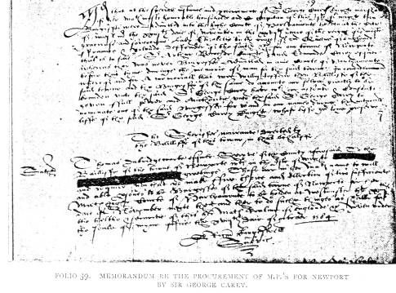

215

“provided that the whole and sole benefitt thereof be trewlie intended for the propper benefitt and advauncement of the meanes of the saied schoole. . . ." Then follow various contributions towards its maintenance, from among others Sir John Oglander, Mr. Edward Cheke, Robert Dillington, John Pittis.
The form of election by pricking which had hitherto been in use, and which in 1620 had given rise to the misdemeanour of Chief Burgess Edward Waterton, was found so unsatisfactory that in August, 1621, at Court of Common Council it was agreed that " whearas heretofore there hath ben difference in opinion amongst the Company concerning the forme of eleccon of the Maior of this Burrough wch hath bred much disputacon and is likelie to cause much confusion in the eleccon . . . from henceforth ….. the Maior and his bretheren who have borne the Cheif office of this Burrough shall yearlie nominate twoe of the foure and twentie Cheife Burgesses to stand in eleccon of Maioraltie of this Burrough, and so being no[m]i[n]ated and their names being written severallie on twoe boxes, one of them so being in eleccon shall be chosen by the voices 'of the whole companie viz* the Maior xxiijtie Chiefe Burgesses or the more parte of them whereof the Maior for the time beinge to bee one, whoe shall ex-presse everie of their voices in this manner, viz* everie of them shall have two little bulles in his hands, the one of them redd and the other white, the wch bullies everie one shall putt one into one box and the other into the other box, and hee of the said twoe in eleccon wth whose name shalbe most white bullies shalbe Maior of the said Burroughe for the yeare next following.
* This entry on folio 53, dorso, is of interest, as describing one, if not the earliest, instance of voting by ballot in England.

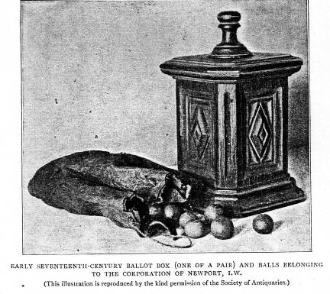
216
The same year, the May-day custom of gathering greenery from Parkhurst having been so much abused, a proclamation was issued :
"Whereas there hath been great spoiles committed in the King's Mat^{ies} woods in the Forest of Parkhurst by the poore people of this Toune .... For the preventing whereof, and for that the fetching of wood out of the forest under pretence of custome is founde rather to encreace the nombre of idle poore in the toune then to relieve the poore (they too much relying uppon the benefytt thereof and so breeding upp their children in Idleness that they be unfitt for anie service, whoe otherwise might be educated in some honest vocacon to gett their living). It is nowe . . . ordered and decreed . . . that the custome and priviledge of the Maior going to the Wood Ovis and the fetching of boughes of Wood out of the forrest shall be utterlie left off yealded uppe and abolished."
In addition to this summary abolition of an ancient and picturesque custom, none of the townspeople, or their servants or children, were at any time of the year " to fetch anie boughes or wood in the saide forrest under anie cullor or pretence whatsoever without speciall leave of his Mat^{ies} Woodwards and Keepers uppon paine to be punished by open whipping," which one would have thought would have met the case without having recourse to the discontinuance of the May outing. The question of an adequate supply of water to the town must always have been a serious one, and, though trmse houses bordering on the river had nothing to complain of, the inhabitants of the southern, central, and western parts must have experienced much difficulty in supplying their wants from inadequate wells. To remedy this a lease of 300 years was granted in 1618 to Philip Fleming "of free libtie for the breaking of anie place or places of the streetes and waies w^{it}hin this Toune & libtie thereof for .the convenient carryeng and conveying of holsome spring water into this toune and so into everye man's house that shall compound w^{th} the said Phillip for the same .... yielding to the warden of the Common Box of this toune ' vl per annum.'" And the said Philip was given leave to build “a cesterne or receptacle for the said water in any convenient place within this Toune." The Corporation added the provisos that the lease should be void if the water was not brought within three years, and that the ground broken should be made good and left as before. It is evident Philip Fleming did not fulfil his agreement, as five years later license was granted, at a court held June 18, 1623, to Andrew James "to dig and breake the streetes to bringe water into & through this Burrough and to build Cisterns Cisterne houses and other convenient receptacles for the same water " (folio 54, dorso). The same year a hogshead of wine was sent the Earl of Southampton as a Christmas present from the Corporation. In 1709, the former projects having apparently turned out failures, another attempt was made to supply the town with water, and a lease of part of the Beast Market, in front of the present I,amb Inn, was granted to William Arnold for a term of 900 years, for'the building thereon of a cistern* to convey " water into from some part of the River running by the North-west part of the Town & from thence to be conveyed by pipes into the principal streets & lanes of the borough, to the end that the Inhabitants might at easy rates be furnished with River water in their houses upon all occasions & might be supplied with a present remedy in case of any accidental calamitous fire." But this scheme proved abortive, and another century elapsed before the subject was again brought forward.
In 1624 one Thomas Bowyer came to Newport "with a deputation concerning Tobacko,"† and at a court holden February 9, "y^{t} is agreed that awnswere shalbe given him that M^{r} Maior and his Companie wilbe better advised concerning the buisines untill tomorrow morning and then to resolve him. And if anie trouble fall on Mr Maior or anie of the Companie by reason of this proceeding the charges shalbe borne by the Toune" (folio 56). The custom of smoking had been inveighed against by the British Solomon in no measured terms, and in 1614 the Star Chamber imposed a tax on tobacco. But
* This reservoir was brought to light in 1790 when repaving the market, and from time to time the old wooden trunk drains are dug up in the streets.
†Tobacco does not appear to have been an expensive luxury, as by the accounts in 1681 eightpence could purchase half a pound of it.

217
three years before the Newport deputation Ben Jonson had roundly abused the weed in his " Metamorphos'd Gypsies." So it is evident the Corporation were not going to be hasty in their answer to Mr. Bowyer. What the morrow's reply was does not appear.
On the last day of March, 1625, a letter was brought from Lord Conway, the Governor, to Sir Edward Dennis and Sir John Oglander, his deputies, directing them to proclaim "the highe and mightie Prince Charles King of Create Brittayne France and Ireland." This the Mayor resented, saying he would do the proclaiming himself, and sent the town clerk and one of the constables to the two knights to demand the proclamation. “The said Sr John Oglander sent word to the said Maior . . . that Sr Edward Denys and hee had appointed y^{t} to be proclaymed the next morning about xi of the Clocke wth solemnitie, and
VOL. VIII.
kept the proclamacon so that y^{t} could not be proclaimed in the meane time by the said Maior and Burgesses according to their desire." All the Corporation could do was to enter their protest in the ledger book, duly signed by John Collins, the Mayor, and eighteen chief burgesses (folio 57).
So determined were the burgesses to keep Newport a close borough against outside traders that an order was issued in September, 1625, forbidding any householder to let to" anie person newe coming to the Toune w^{ch} is of anie trade or occupacon "... without consent of the Mayor and chief burgesses, under a penalty of five pounds; and five years later an unfortunate outside draper, trying to set up shop, it was resolved . . . " that the said John Wavell shall be opposed and resisted by the whole Corporacon as farre as lawe & the Charters of this Burrough will afford & that the charge therof shalbe borne by the whole Corporacon.

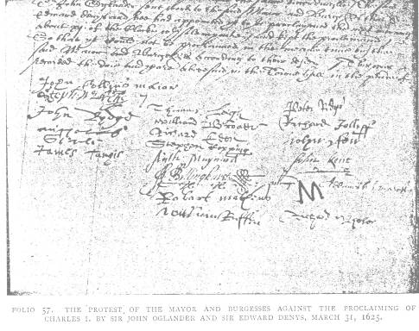

218

In 1632 it was agreed a new and extended charter should be obtained, and that the Mayor should ride to London on the business, his travelling allowance being rated at 5s.. a day; and to prevent undue loitering a rider was added that his journey was not to exceed fourteen days.
Besides the usual compulsory training in archery, and the maintenance of public butts, a regular trained band for the town was established on a systematic footing. In 1625 the trained band of Newport numbered 304 men, consisting of 22 officers, 94 musketeers,* 4 " collivers " (arquebusiers), 12 "corslettes" (cuirassiers), 32 pikemen, 10 halberdiers, and 130 men of various arms.
By an entry on folio 62, dorso, under date June 21, 1663: "It is agreed that the " Inhabitants of this Burrough shall be divided into twoe Companies, for ye muster whereof one Company to be under the Command of the Maior, & the other under the comand of Stephen March Esqr, and that lotts should be cast betweene the newe Maior & Mr March wch should have the Est or West pt of the towne, being divided from Cosham Stile to Somers Brooke—the west pt of Hollirood Streete & widd. Parsons and Abraham Stallards to be added to the east pt. Wherupon lotts being cast the west pt fallen to Mr Maior & the East pt to Mr March. And both to have the Towne Cullors of white and greene † with some little distinction to be knowen one from the other & to be prowided by the toune & to remaine to the toune." Mr. Anthony Locke was appointed drill-sergeant to both Companies, and received his pay by a levy of 6d. on each musket and corselet, and 4d. on every pike, " so long as he shall supplie and exercise that place uppon everie one that findes the armes themselves." The following month " Fyftie Corsletts com-pleat furnished with a pike belt and sword to every of them, and twentie musketts furnished wth a rest bandoleere touch-box belt and sword to every of them," were issued by order of the Earl of Portland from Caris-.brooke Castle to the burgesses of Newport " for better improvement of his Maties forces
* Every musketeer was furnished with 3 Ib. of powder, 2 Ib. of match, and fifty bullets, by an order of 1642.
†The old Tudor colours.
in the same Burrough." Nine years later this loyal trained band, under its Puritan Mayor, was the chief factor in capturing the Castle of Carisbrooke for the Parliament from the Earl's high-spirited Countess.

(To be concluded.} see p.304

304
The Ledger Book of Newport, I.W , 1567-1799.
by Percy G. Stone, F.S.A..
(Concluded from p. 218.)

The collection of Ship-money was as difficult in the Island as elsewhere, as the Sheriff, Sir John Oglander, found out. The contumacy of Winchester was followed by that of Newport, and in January, 1640, we find the Corporation "enforming the Parliament House of the abuse of the Sherive's Bailiff in taking away the Maior's goune for Shipp money." In March of the same year Lucius Gary Viscount Falkland, and Sir Henry Worsley, Bart., were elected the town's representatives to sit in what became known as the Long Parliament (folio 68d). Three years later their elder member, Charles's Secretary of State, an even-minded man, with whom the times were out of joint, threw himself into the thick of Newbury fight, and found the death he sought at that fatal hedge-gap by the-Rennet. On folio 69 this tragic event is noticed in the following unsympathetic manner: " Whereas Lucy Viscount Faulkland formerly chosen by you to be one of the Burgesses of yor Burrowe for this Parliament was sithence by the Judgement of the Commons of the Lower house of Parliament judged incapable longer to sitt as a member therof and since, as is reported, is deade." So runs the precept of Thomas Bettesworth, the High Sheriff, who bids them choose "another fitt and able man . .". in the place
of the said Lucy." The warrant came down November 18, 1645, and William Stephens* was returned by an overwhelming majority. In 1651 there appears to have been a petty schism in the Corporation, and a Mr. Edward Rawlins, one of the Chief Burgesses, set himself up as
"Mayor of Crocker Street," and addressed the following insulting letter to two of the principal members of the Council: "Crocker Streete. Uppon complaint to me made by the Recorder of the same streete against you. Theis are to order your appearance before mee at the Townehall of the saide streete on sight of this my warrant. Given under the Scale of my Mayoralty and dated the sixth of October 1651. Edward Rawlins Mayer.
“To Phillipp March, Esqr and Robert Gother, Inneholder theis.”
The only notice taken of this was the resolution passed at the next Council meeting " that the said Edward Rawlins bee from henceforth and is nowe absolutely dismissed from being a Cheife Burgesse of this Bur-rough" (folio "70d). The same year the burgesses seem to have arrived at the conclusion that the Mayor had quite enough to do with the civil business of the town without being called on to captain the militia, so a resolution was passed: " It is thought fitt and agreed by the Mayor & Burgesses nowe assembled that Mr George Searle shalbe constantly† Captaine of the Company w^{ch} have heertofore ben commanded by the Mayor of this Burrough. . . ."
The difficulty of maintaining an incumbent to serve the Church of St. Thomas was met by a resolution in 1652 "to sett a tax upon all the lands & Inhabitants of this Burrough towards the yearly maintenance of a Godly minister to bee settled in this Burrough," but seems to have met with some opposition (folio 72). The estates of suicides were evidently a perquisite of the Corporation, as in the same year the Mayor " delivered in an accompt of 24 li. 2s. 2d. by him receaved of the goodes and chattells of Downer whoe lately murthered himselfe wthin this Toune,"
* Receiver under the Parliament for forfeited lands of bishops, deans, and chapters. Appointed steward and bailiff of Isle of Wight 1642 ; died 1659.
† From this expression Mr. Searle was probably the Mayor's deputy, and did most of the work.

306

which money had been laid out in repaying the Corn Market (folio 73). At this time the maces were ordered to be " newe made both of one biginesse and five pounds, or thereabouts, is to be added for the making them bigger, to be paid by the Toune Warden "; and thus disappeared the ancient borough maces which, by the drawing of the swearing-in of the bailiffs, were similar to those of Newtown and Yarmouth, still happily in existence. The Cistern-house in Quay Street, erected probably in 1623, had evidently become useless, as it was ordered to be demolished, and the proceeds of the materials applied to the repair of the street, “broken upp by the water worke from the stoppcocke at the fish shambles to Mr Denyes dore"; so the supply was still in working order. Every street appears to have had its two Vintoners, or petty Constables, and as this became a burden, usually falling "on poore labouring men who are not able to properly discharge it," it was ordered in 1653 that in future "there shalbe onely eight vintners ... for the whole Burrough elected and chosen," half for the east and half for the west division of the town, the divisions being subdivided into north and south.
The question of the spiritual needs of the borough and the support of an incumbent seems still to have been a serious one, and at a meeting held March 17, 1653, it was decreed: " Wheras this toune and Burrough is become very Populous consisting of 2500 soules and upwards, and the Church or Chapell therof is not endowed wth any meanes or maintenance for the subsistance or lively-hood of any minister or ministers to preach the word of God, or officiate therein as a minister or ministers. By meanes wherof all Godly ministers are utterly discouraged to take the care and burthen of the said place and people upon themselves, to the great damage and eternall hazard of the soules of the poore Inhabitants of this same toune ... a tax, not exceeding the some of one shilling & sixpence upon every pound for one whole yeare, bee made uppon all the lands and tenements lying w'hin the same Burrough & also on all the rents and personall estates of all the Inhabitants residing wthin the aforesaid Burrough." This passed without dissentients, and Robert
VOL. VIII.
Tutchin was appointed minister at the modest stipend of "Threescore and Fifteene poundes by the yeare." The ministry in Newport certainly did not prosper under the Puritan regime, and this rate does not appear to have been popular, as the collectors were bidden to levy distress on the goods of those refusing to pay (folio 79^). It is evident they couldn't raise the £75 of the minister's salary, as Robert Tutchin, having received an offer of another living, said he would stay if the Corporation would give him £50 a year and a house,* which they promised to do (folio 84^).
In respect of new buildings, drawings seem to have been first submitted to the Corporation, as was the case in 1656, when a Mr. Richard Rudyard, having purchased the leases of a house next the shambles, and four of the butchers' shops adjoining, " at neere 200li charge, wch is a very deere rate," proposed to pull them down, and " builde a hansome structure, according to the modell now by him presented to this assembly . . . wch will cost him neere foure hundred pounds " (folio 79). In 1661 a new charter was obtained, which is the one by which the Corporation is now governed. This was produced at the Council meeting held January 10, 1661, when ''all took the oaths of Supremacy & Allegiance except John Chatfield and Henry Ringwood," the latter withdrawing from " the Toun Hall ... in a passionate maner." The two dissentients were in due course dismissed the office of Chief Burgess. Curious it is that this loyal assembly was presided over by Moses Read, the leader of the Puritan attack on the Castle in 1642.
In 1662 the master of the Grammar School, Thomas Thactham, was given “warning to depart this said schoole at the end of twelve

* November 5, 1652, it was agreed "'That the lease formerly graunted unto Mr Nicholas Serle of a Tenement called Coppid hall wth the backside outhouses and garden plott, conteyning by estimacon a place of ground, togeather with a close called But close, conteyning by estimacon one acar, be not renewed but be lett runn out untill it comes into the hands of the Toune, it being intended then to be for the use of the Minister of the Toune, he paying the quitt rent for the same" (folio 73d).
† Nine years after this show of temper he repented of his contumacy, took the oaths, and was re-admitted to the Council (folio 125).

307
moneths now next ensueing " by reason " he doth undertake a Cure of Soules at Carisbrooke, doth often marry and baptize"— which must rather have interfered with his scholastic duties — "& hath given unto severall of his schollars unreasonable correction and doth otherwise neglect his said schoole, whereby the same is very much decayed." Altogether a somewhat unsatisfactory schoolmaster it was well to get rid of. The abuse by strangers of the privilege of "freeman" trading seems to have been a constant source of complaint, and in 1662 not only were such warned not to exercise any art, mystery, trade, or occupation, " without the special license & consent" of the Corporation, but also that they must be severally " registered by the Common Clerk . . . in a book by him to be kept for that purpose" (folio 94). In the following year four more burgesses, Messrs. Ridge, Jolliffe, Dore, and Reynolds, refusing to take the oaths of Supremacy and Allegiance, were ordered to be dismissed their offices. On folios 103-118 is a copy of the extended charter of Charles II. Under this the Corporation officers consisted of the Mayor, eleven Chief Burgesses, ten Aldermen, two Chief and eight Petty Constables, a searcher, a sealer and a registrar of leather, two viewers of the Corn Market, two viewers of the Butchers Shambles, and two viewers of the gashing of hides, four measurers, two viewers of the Cheese Cross;* an ale-taster, a gauger, a piggard, a pounder, and a whipper. There seems to have been some sort of Public Library in Newport, as at a Court, held August 12, 1680, "was produced a parchm* Roll conteyning the subscription Mayor ellected to his Maties Castle of Caris-brooke where he the said Mr. Lyne was in due manner and forme" sworn in " in the Chappell of the said Castle before the Governour's steward of the Island" in the Governor's absence, the first mention of this ceremony being" performed in the Chapel of St. Nicholas, and which continued till the end of the eighteenth century. Seats in the choir of the parish church seem to have been early allotted to the Corporation, and in a copy of the Faculty, dated September 27, 1616 (folio 132^), mention is made of ten seats, five on either side, into which " some thinking better of themselves than there is cause why, have by their private authority thrust themselves without all good order into the same scales, whereby the dignitie and creditt of the said place is much impeached." The document goes on to state that the Mayor and Corporation are to occupy the seats quietly and peaceably, and that any persons opposing them are to be excommunicated. They must have got somewhat out of use, as in 1684 it was agreed that any persons paying half a crown should " have the Priveledge of sitting in the two Burgesses seates next to the Communion table," the money being spent on the repair of the Corporation seats (folio 132). In 1685 occurs the first entry of a medical officer, one Thomas Stockwell, to whom " Freedom of this toune is granted ... to use & exercise the Art mystery or trade of a Barber Chirurgeon within the Burrough and to keepe a shopp" (folio 135). The four town watchmen were in 1686 reduced to three, "one of which shall be Flower who is to walke the rounde with his Bell * twice every night, & while he attends in the markett the other two watchmen are to walke the rounde once every night," so Mr. Flower evidently had to do the work of the other two. A town fire-engine seems to have also been an institution, and was kept in the west end of the north aisle of the church, and looked after by the overseers of the poor, it being agreed and ordered in 1687, " that for the time to come the engine standinge in the Church to be used in time of Fire in this towne shall from time to time be repaired and kept in goods

In the accounts of 1680 occurs the item, "a coate for the Bellman £i 5.1. jd."

of those Gents who gave moneys towards a Library," which, amounting to £48, was ordered to be paid to " Sir Benjamin Newland in London . . . for the books that shall be bought ..." (folio 129). The next folio, 130, is cut out, the only mutilation in the book.
After a Council meeting, held September, 26, 1684, is the following memorandum at the end of the minutes : " Att which time all the company aforesaid went from the Guildhall of the said Burrough and accompanied Mr Mayor and Mr Wm Lyne the

*This stood at the end of the shambles, to the north-east of the church.

order for that purpose by the overseer of the poore of this town for the time beinge, it beinge a publiqk instrument provided for the benefitt & advantage of all the inhabitants of this Toune in Case of Fire" (folio 137). In January, 1689, Sir Robert Dillington, Bart., and Sir William Stephens, Kt., were selected by the burgesses, in answer to the Prince of Orange's letter to the Corporation, to represent the borough in the Convention summoned for January 22, which declared the Throne Vacant. The candidates' names were underwritten, and the election over, "the sd paper was imediately burned "— a just precaution in those topsy-turvy times (folio 142). An entry of July 7, 1703, exposes the conduct of a Chief Burgess, who one would have thought ought to have known better: " Whereas Mr John How one of the Chief Burgesses of this Burrough doth keep a publiq Ale house in this Toune wthout a license of the Justices ... & having been required to leave off keeping the said Ale house hath in a scornfull manner refused so to doe in contempt of the law in that behalfe, and hath also suffered his gowne in a scandalous manner to be worne by a common bayliffs wife in contempt of the Queen's authority & the government of this towne. Therefore by the unanimous consent & agreem^{nt} of all this Company now assembled he the sd John How is dismissed of and discharged from his sd office & from the fellowship & society of this Corporacon." What Mr. How thought of this fulmination does not appear, but six months elapsed before he came in his own " propper person and freely and voluntarily surrendered and yeilded up his office of a cheif Burgess "— note the freely and voluntarily—which “same surrender is accordingly accepted" (folio 161). In 1709 a burgess, Mr. John Foquett, " who died in the East Indies gave to the poore of this towne two hundred pagodas wch amount in English money to 95"." His executor, however, one “Thomas Alleyne of London Salter," refused to pay this unless £15 was allowed him for expenses,” wch being complied wth after many delays," he disbursed the money (folio 164 d).
On August 9, 1714, "all members of this Corporation above named being assembled in the Toune Hall went thence in their
formalities attended with the Cheif Constables Petty Constables wth their Staves and the two Serjeants wth the Toune Maces, all in due order, into the most publiq place in the High Street when in due and Solempne manner in the presence of abundance of people was publickly proclaymed his most excellent Maytv George by the Grace of God King of Great Britaine France and Ireland Defender of the Faith etc wth great acclamation rejoicings etc God save the King."
Thus was the first representative of the House of Hanover proclaimed at Newport. There was a contention at the Mayor's election in the Church in 1715, when "there were eight White Bulletts in the Box on wch Mr Thomas Ridge's name was sett and none in the Box on wch Mr Henry Woodford's name was sett." So Mr. Ridge was declared duly elected by his supporters, but "there were eleven of ye Corporation who voted seperately in an hatt ... for Mr James Grant ... & there uppon the said James Grant is by those eleaven voters declared Mayor." Neither side would give way, so the two candidates attended at the Castle to be sworn in. The Lieutenant-Governor, however, " refused to sweare the said Mr Thomas Ridge who thereuppon withdrew," and Mr. Grant was duly sworn in Mayor (folio 169). But this unconstitutional method of voting was not to end here, and Mr. Grant's legal status was challenged the following year, when a protest * was lodged against the return of his successor, John Redstone, " because that supposed election was made under Mr James Grant who then acted as Mayor tho' he was not legally so." Mr. Redstone, however, was sworn in at the Castle, and subscribed the " three oaths menconed and enjoyned in the Act of Parliament for the further security of his Majties person and Government and the Succession of the Crowne in the Heires of the late Princess Sophia and for extinguishing the hopes of the pretended prince of Wales and his open & secret abettors, and also making and subscribing the Declaration against Tran-substantiation and the Covenant " (fol. 171).
The Ledger Book now draws to a close with long lists of Mayors, Constables, and
*Newport MSS., Convocation Books, vol. ii., p. 561.

308

Free Burgesses from 1555 to 1799, and the whole concludes with a copy of the agreement between the bailiffs and the Somerset Clothiers or Woolmen in 1578 concerning the payment of petty Custom—i.e., " for any lode of Wool conteyning two sackes and a Ryder ijs vjd that is to saye xijd for every sacke & vjd for the ryder." And the clothiers are to " receive of the handes of the baylives for the tyme being there cockatts for the transporting of there sackes of woll," paying a fixed fee of fourpence. In consideration of which payment the bailiffs agree " henceforth to not demand or receive the petite customes for wolles according to there customarye of ob. q ^{r} * the tode nor to vex or trouble any of them." The document is signed by Sir Edward Horsey, Captain of the Island, the two bailiffs, Newnam and Serle, and five clothiers who subscribe their marks.
Such is the old Ledger Book of Newport, which I have endeavoured to make tell its own tale by extracts—a tale not without interest, describing the conduct and organization during three centuries of one of the oldest boroughs in England. Curiously enough, there is no mention, beyond an item of cost in a yearly account, of the Spanish Armada, whose first encounter was off the Wight, and none at all of the unfortunate Charles I., who spent three months of his years' detention in the Island within the very town itself during the historical Treaty of Newport.

the th a vengeance.

