Charles Powlett, 3rd. Duke of Bolton.

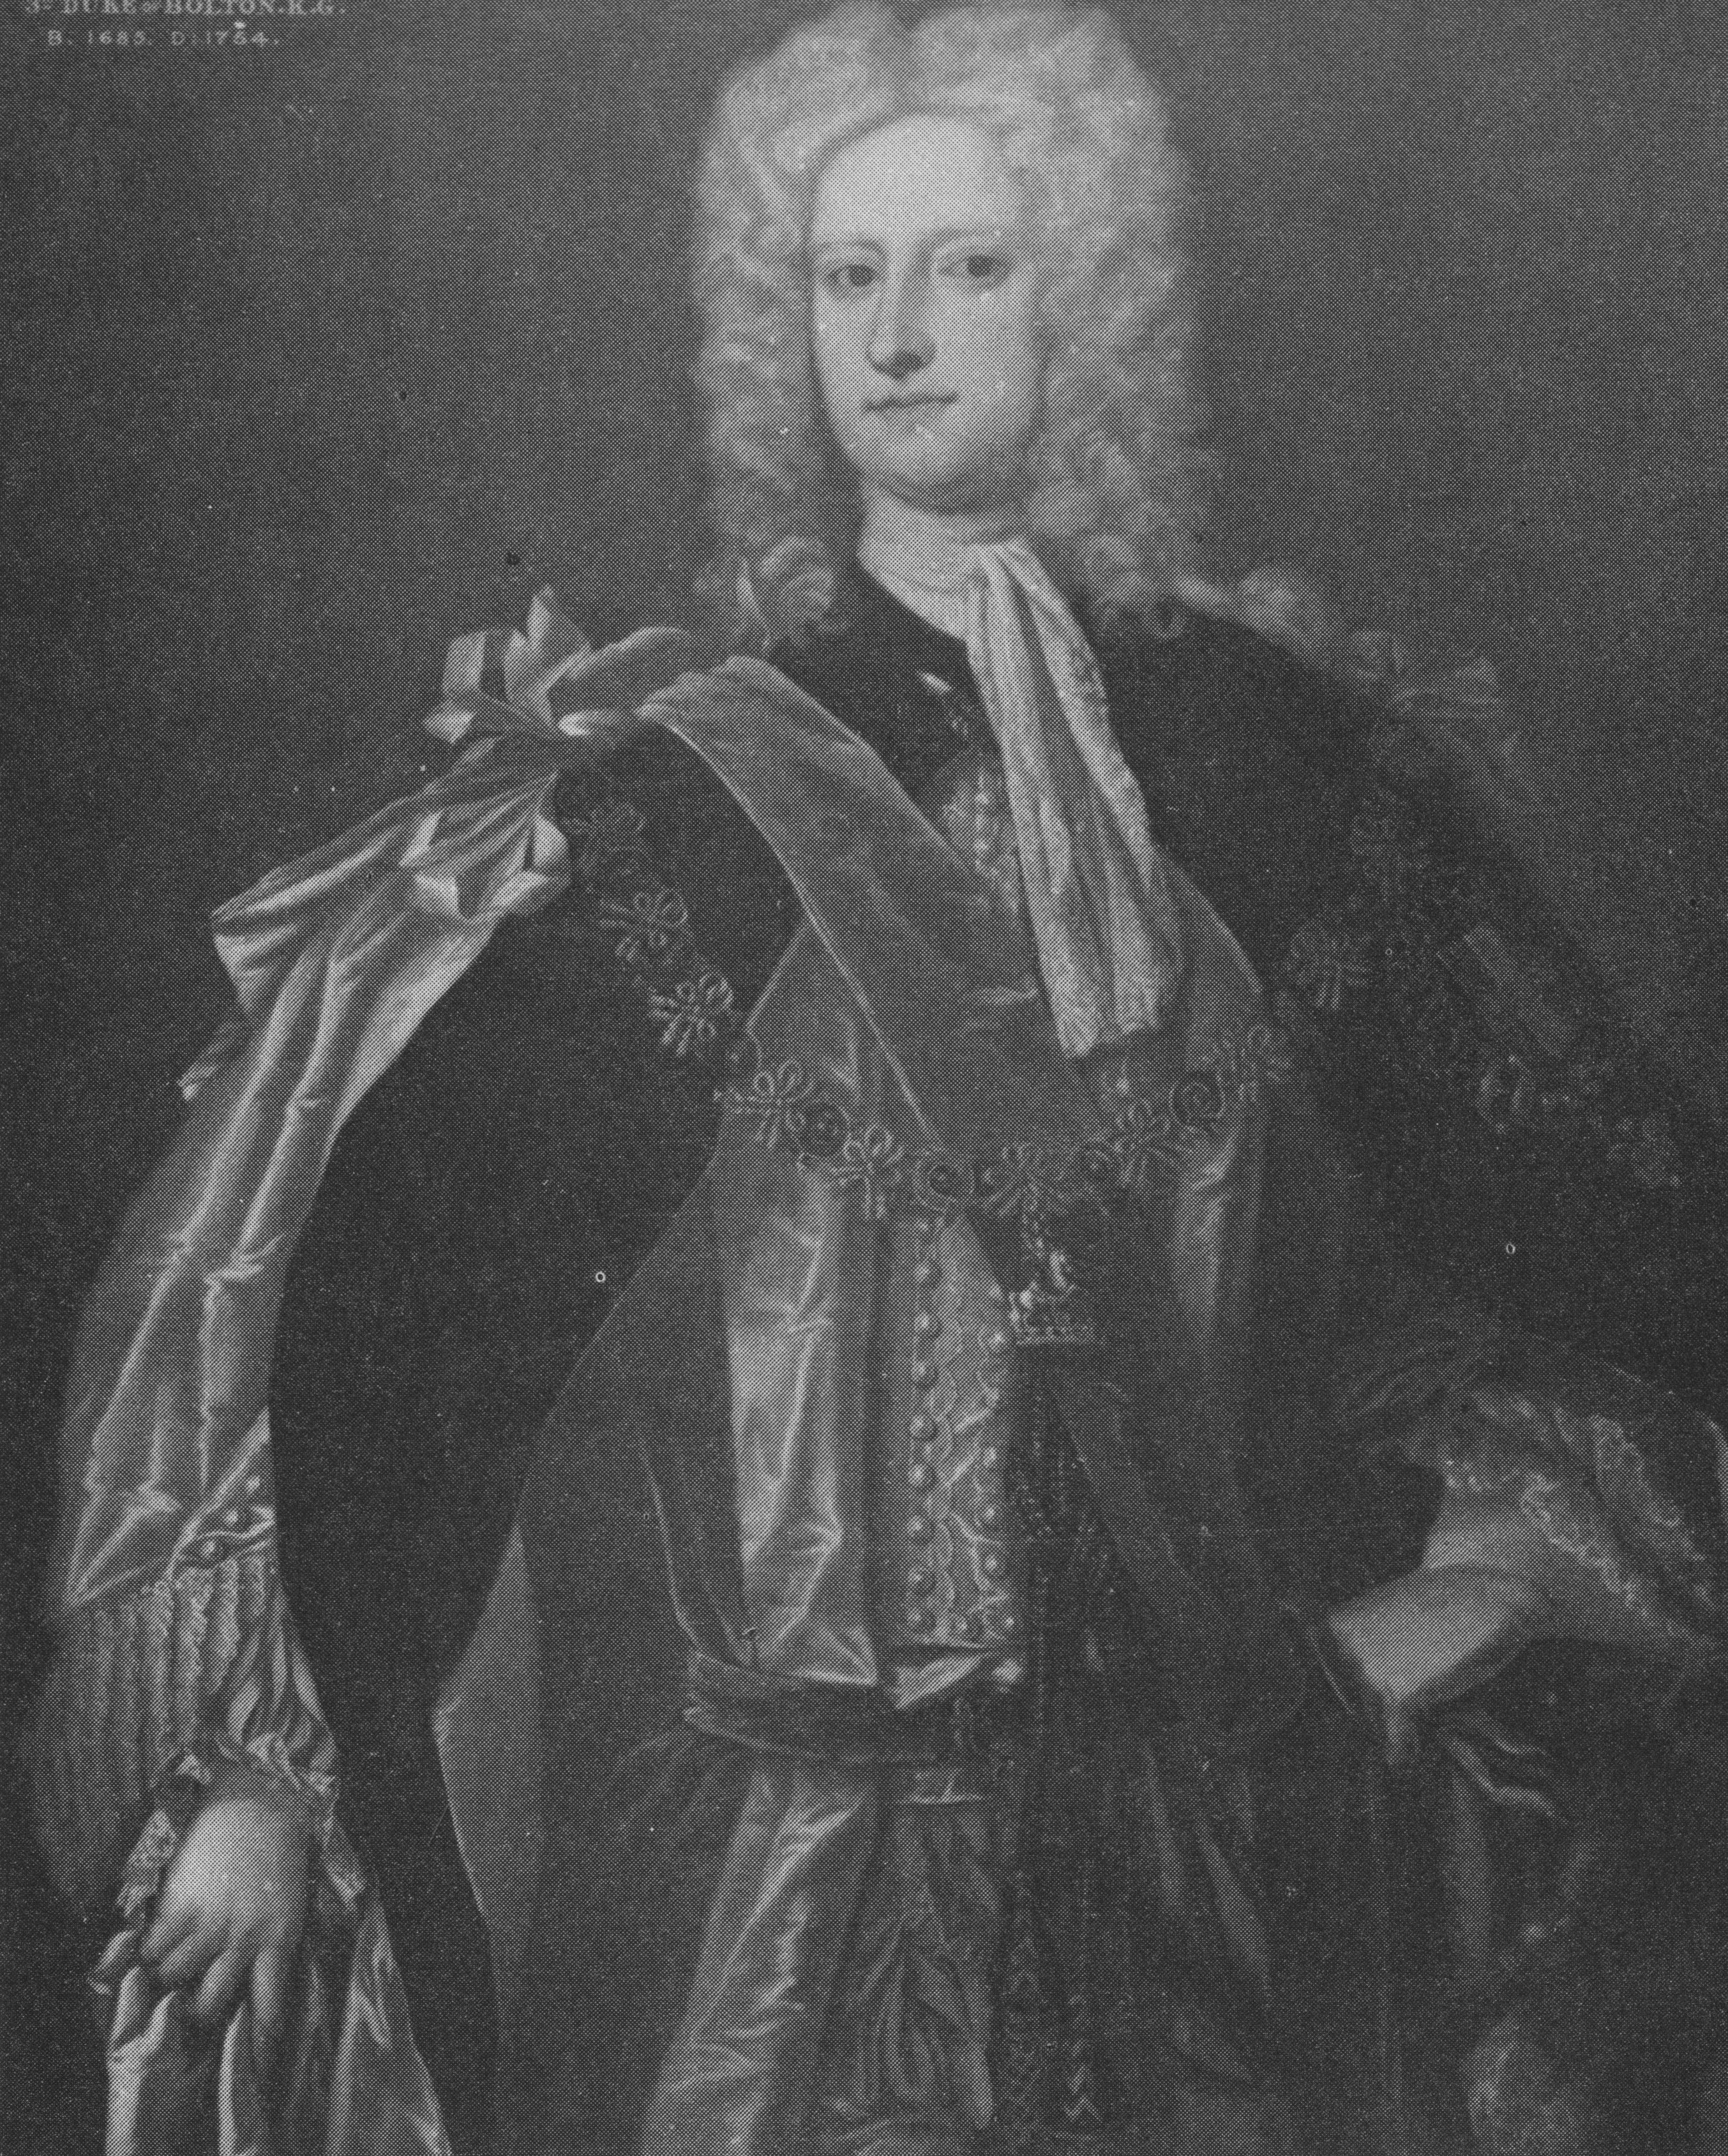

Sir Charles Powlett (Paulet) 3rd Duke of Bolton,
8th. Marquis of Winchester and Baron Basing, 1685-1754
Eldest son of Sir Charles Paulet, 2nd Duke of Bolton was summoned to the House of Lords as Lord Basing (1717): deprived of all his places because of his opposition to Walpole; D.N.B.

